

**USER GUIDE**

**HYPER TASK**

|  |  |  |
| --- | --- | --- |
| **Supervisor:** | *NGUYEN NGO PHUOC* | |
| **Semester:** | *3* | |
| **Batch No:** | *T1.1908.E0* | |
| **Group No:** | *02* | |
| **Order:** | **Full name** | **Roll No.** |
| *1.* | *Duong Ngoc Hai* | Student1198484 |
| *2.* | *Nguyen Hien Long* | Student1198731 |
| *3.* | *Nguyen Xuan Phong* | Student1198583 |
| *4.* | *Le Tuan Khang* | Student1204495 |

***Month****: 08* ***Year****: 2021*

# TABLE OF CONTENTS

TABLE OF CONTENTS i

TABLE OF FIGURE ii

1. Login Page 1

2. Register Page 2

3. Header 4

4. Dashboard page 5

5. Features page 8

6. About us 9

7. Profile page 10

8. User’s activity page 11

9. User’s card page 12

10. Contact page 13

11. Change password page 16

12. Boards page 17

13. Board details page 18

14. Chat component 29

15. Note page 30

16. Calendar page 31

# TABLE OF FIGURE

Figure 1. Login Page 1

Figure 2. Login Error 2

Figure 3. Register page 2

Figure 4. Register validation 3

Figure 5. Header 4

Figure 6. Dashboard page 5

Figure 7. Overview tab #1 6

Figure 8. Overview tab #2 6

Figure 9. Member tab 7

Figure 10. Report tab 7

Figure 11. Feature page 8

Figure 12. About us pagee 9

Figure 13. Profile page 10

Figure 14. Upload avatar popup 10

Figure 15. User activities page 11

Figure 16. User activities page 12

Figure 17. Card on board 12

Figure 18. Add contact tab 13

Figure 19. QR code scan #1 13

Figure 20. QR code scan #2 14

Figure 21. Sent invitation tab 14

Figure 22. Received invitation 15

Figure 23. Contact tab 15

Figure 24. Change password page 16

Figure 25. Boards page 17

Figure 26. Create new boards 18

Figure 27. New created board 18

Figure 28. Rename board 19

Figure 29. Add member to board 19

Figure 30. Search all user 20

Figure 31. Add user to board 20

Figure 32. Board activities 21

Figure 33. Board setting 21

Figure 34. Board background select 22

Figure 35. Allow user to edit board 22

Figure 36. Create a list 23

Figure 37. Edit list name 23

Figure 38. Add card 24

Figure 39. Card detail dialog 24

Figure 40. Add date to card 25

Figure 41. Add label to card 25

Figure 42. Add member to card 26

Figure 43. Add attachment to card 26

Figure 44. Add check list to card 27

Figure 45. Remove card 27

Figure 46. Order list 28

Figure 47. Order card 28

Figure 48. Chat side bar 29

Figure 49. Chat panel 29

Figure 50. Note page 30

Figure 51. Create new note 30

Figure 52. Modify note labels 31

Figure 53. Calendar page 31

Figure 54. Card detail page 32

# Login Page

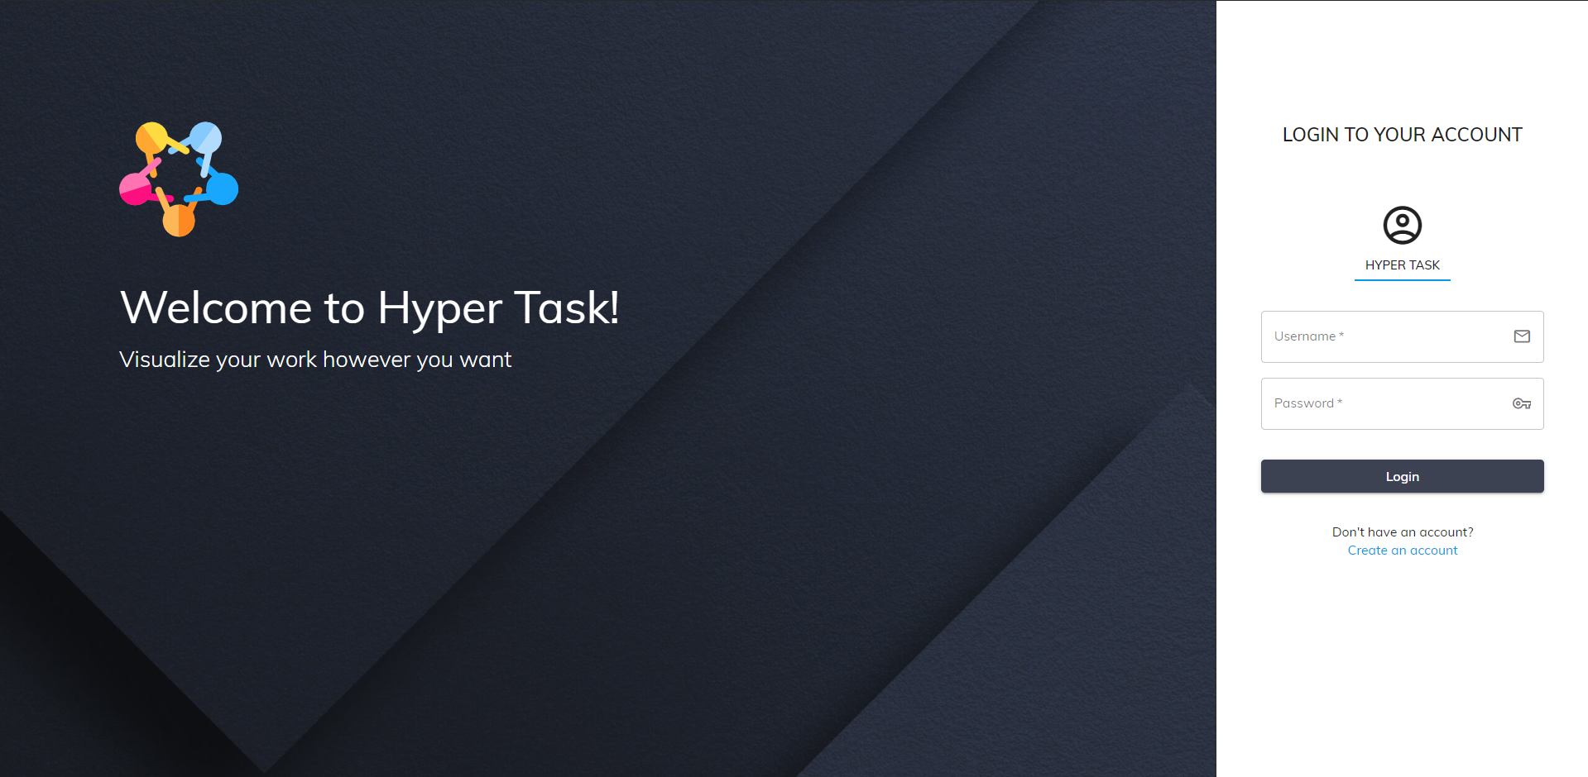

1. Login Page

The login page is the first page a user lands on a website. In the Login page, users can access the page by filling in the fields “Email or username” and “Password” (In case they have an account). If “Email” and “Password” are correct, the system will notify successful login and return to the homepage. If the account is wrong, there will be a message and proceed to log in again. Even if the user closes the web, on the next visit, they don't need to log in again until they log out.

**Attention**: Users must follow these rules.

|  |  |
| --- | --- |
| **Field Name** | **Rules** |
| Email or username | Required and have to correct with email or username they have register |
| Password | Required |

* Login Page errors when not follow the rule

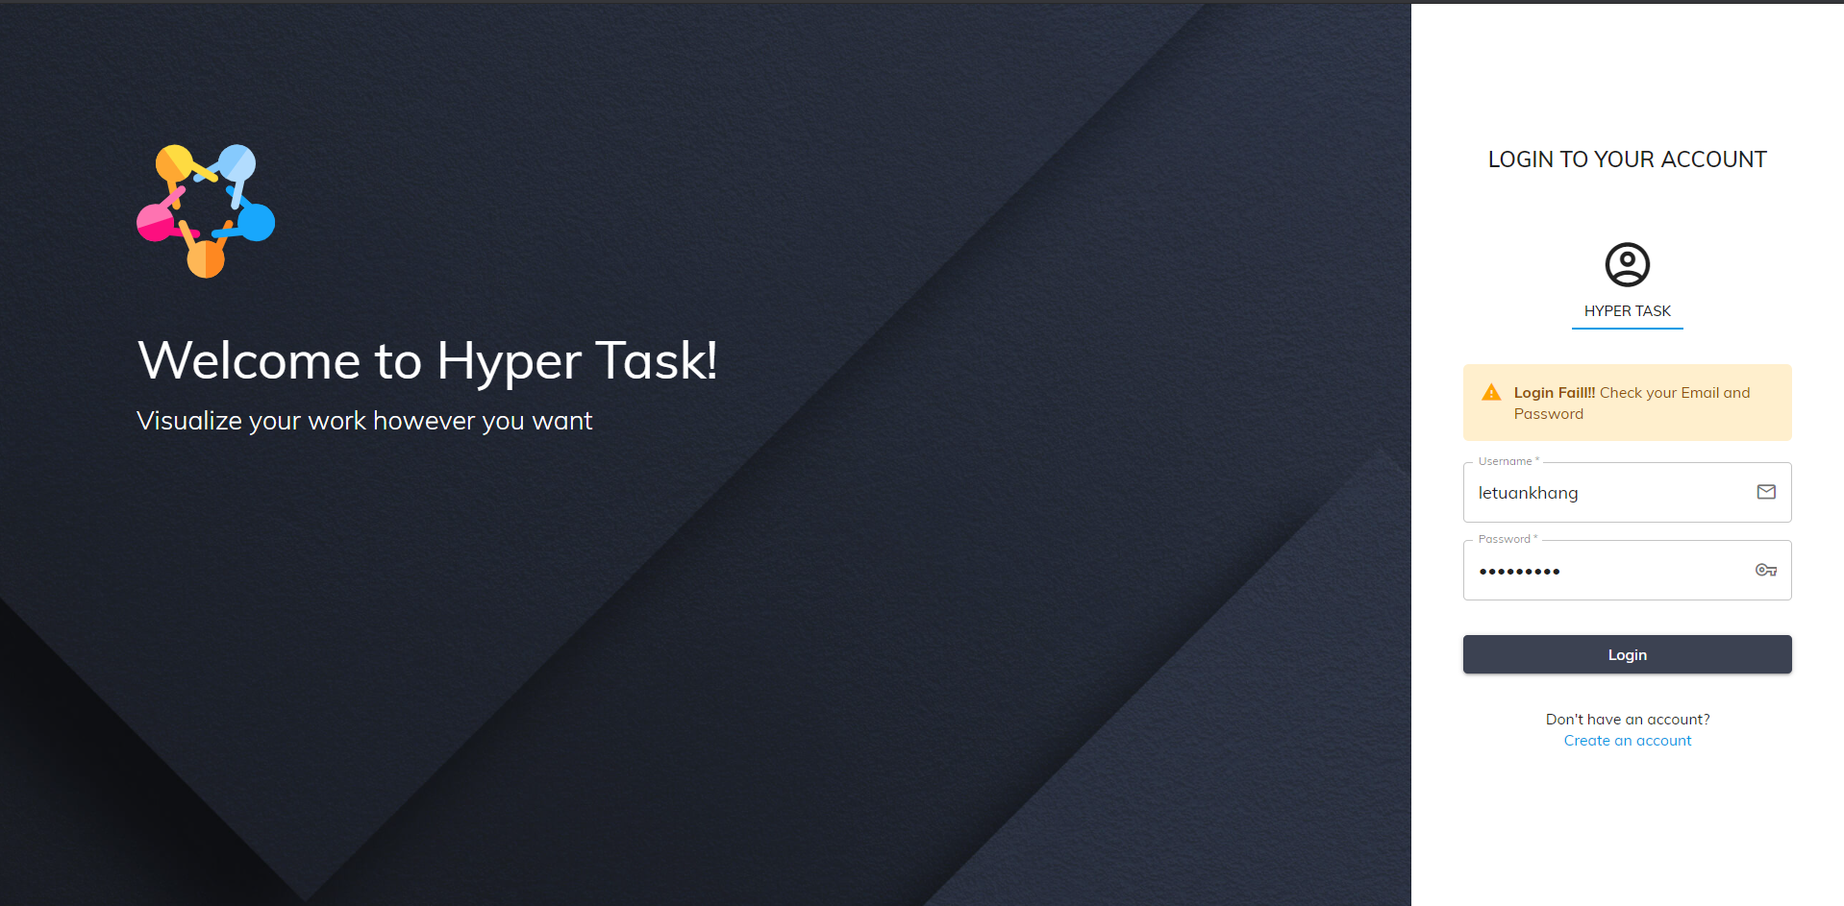

1. Login Error

# Register Page

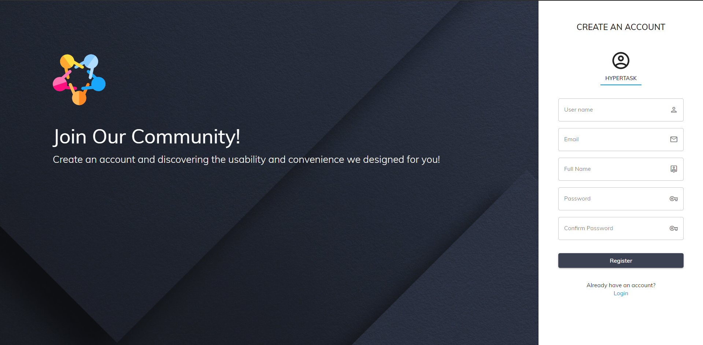

1. Register page

Registration page (Register), users can create new accounts to perform tasks on Hyper Task. Once the user fills in all the required fields correctly according to the website instructions, they can click Register to create their new account.

**Attention**: Users must follow the following rules:

|  |  |
| --- | --- |
| **Field Name** | **Rules** |
| Username | Minimum 5 characters with no special characters and not the same as registered usernames |
| Email | Minimum 5 characters with no special characters and not the same as registered email |
| FullName | Does not contain special characters that may contain Vietnamese letters |
| Password | Minimum 6 characters |
| Password confirm | Minimum 6 characters and must be the same as the password |

* **Register page errors when not follow the rule**

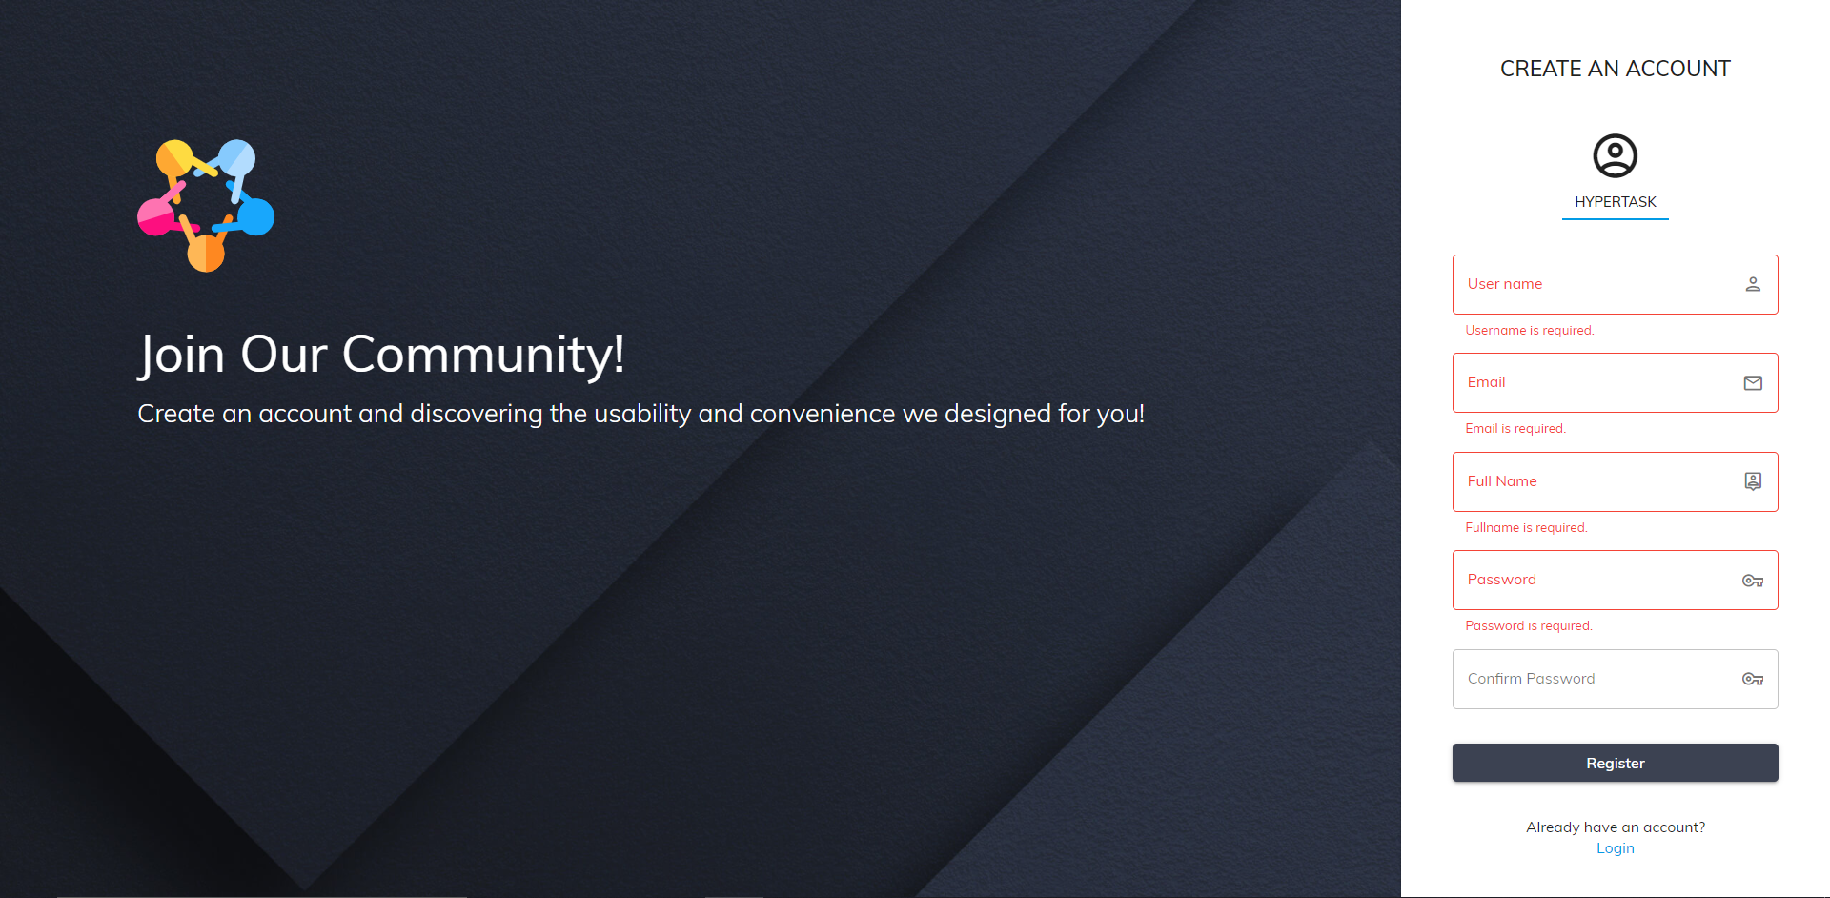

1. Register validation

# Header

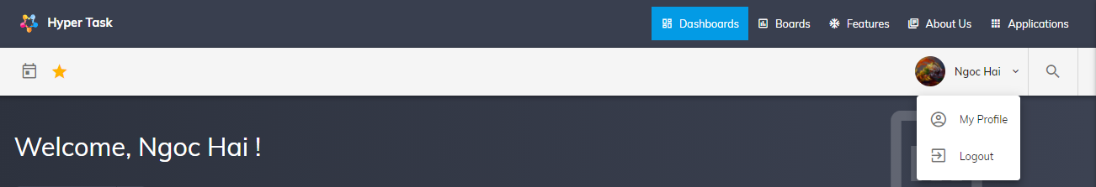

1. Header

This section is called Header, which is always on top of all pages, Header section includes:

* Website name: users can return to the homepage at any time by clicking on the logo.
* The titles of the component pages:
* Dashboard
* Boards
* Features
* About Us
* Application: Calendar app and Note app.

# Dashboard page

Introduction of the website with hyperlink at the top (for navigation). Dashboard gives a current summary, in graphic, easy-to-read form, of key information relating to progress and performance, especially of a board or a project.

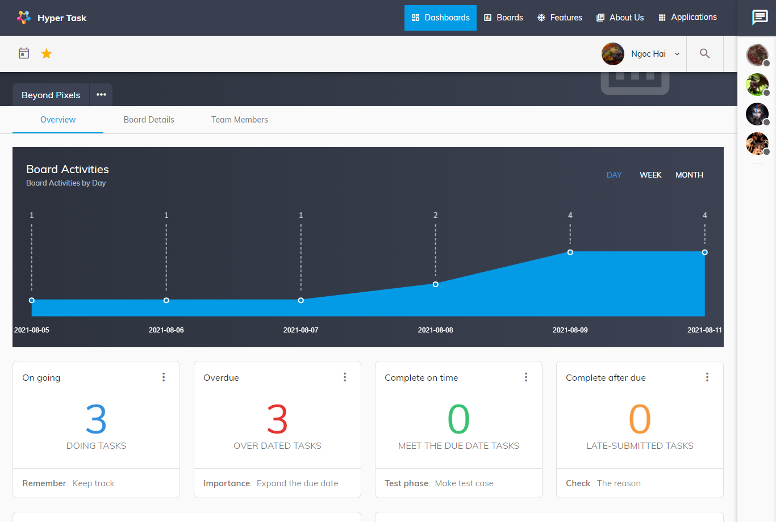

1. Dashboard page

Dashboard contains three tabs:

* Overview: This tab contains many charts & widgets that showing multiple boards data:
* Chart: Board activities, task by labels.
* Widget: Doing tasks, over-dated tasks, complete on time tasks, complete after duedate tasks.

And the list that showing tasks by category selected on widget.

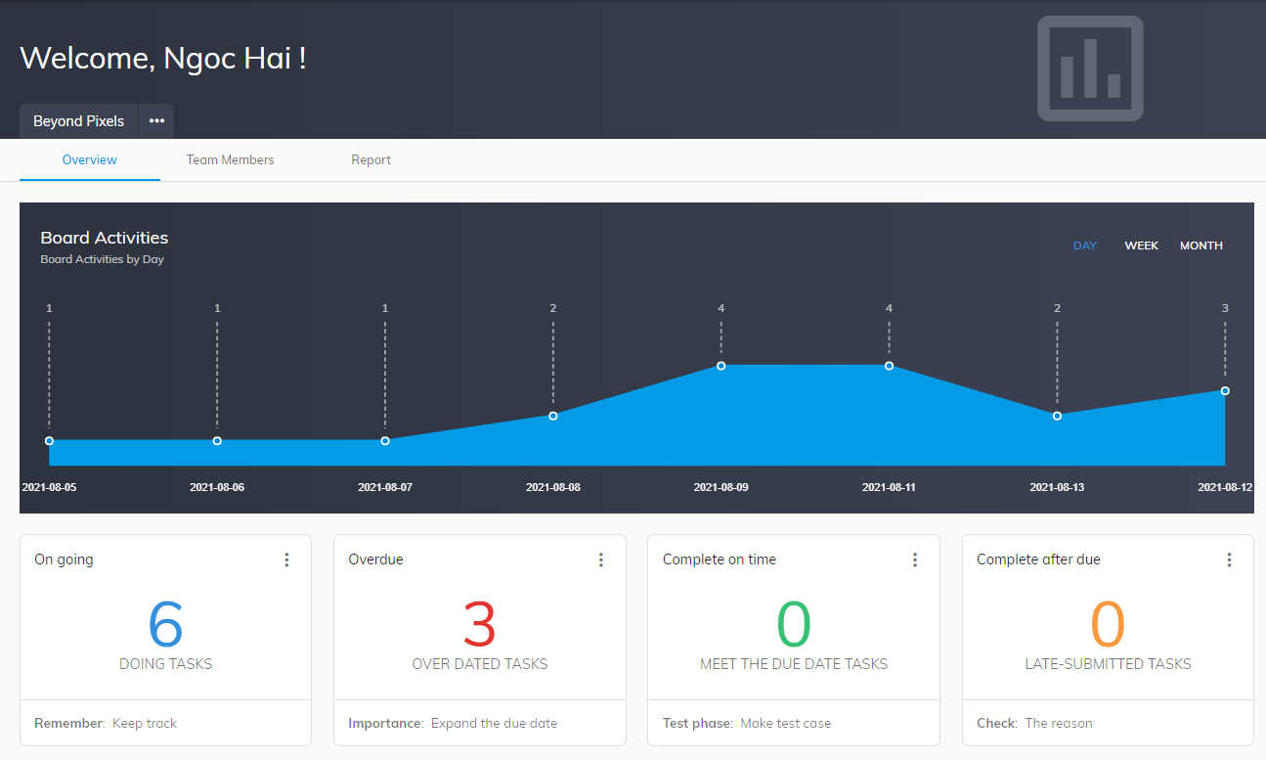

1. Overview tab #1

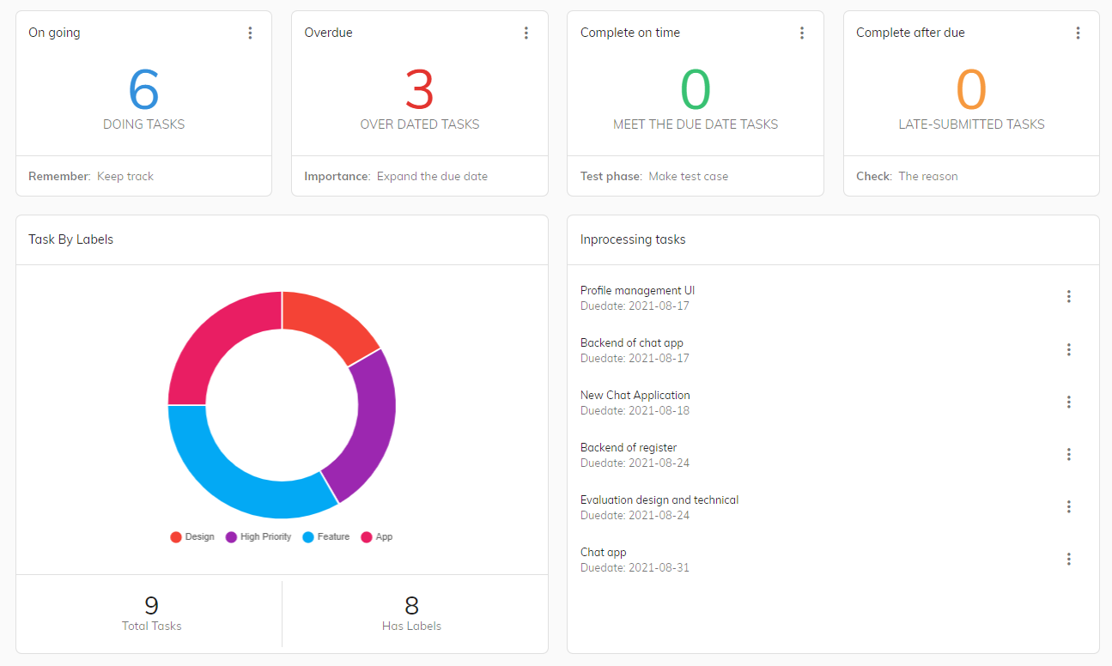

1. Overview tab #2

* Members: showing member of boards and their information.

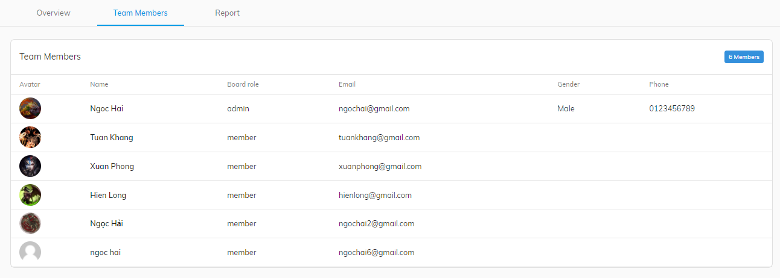

1. Member tab

* Report: display total information of the boards, user can view to know details and export them for storing.

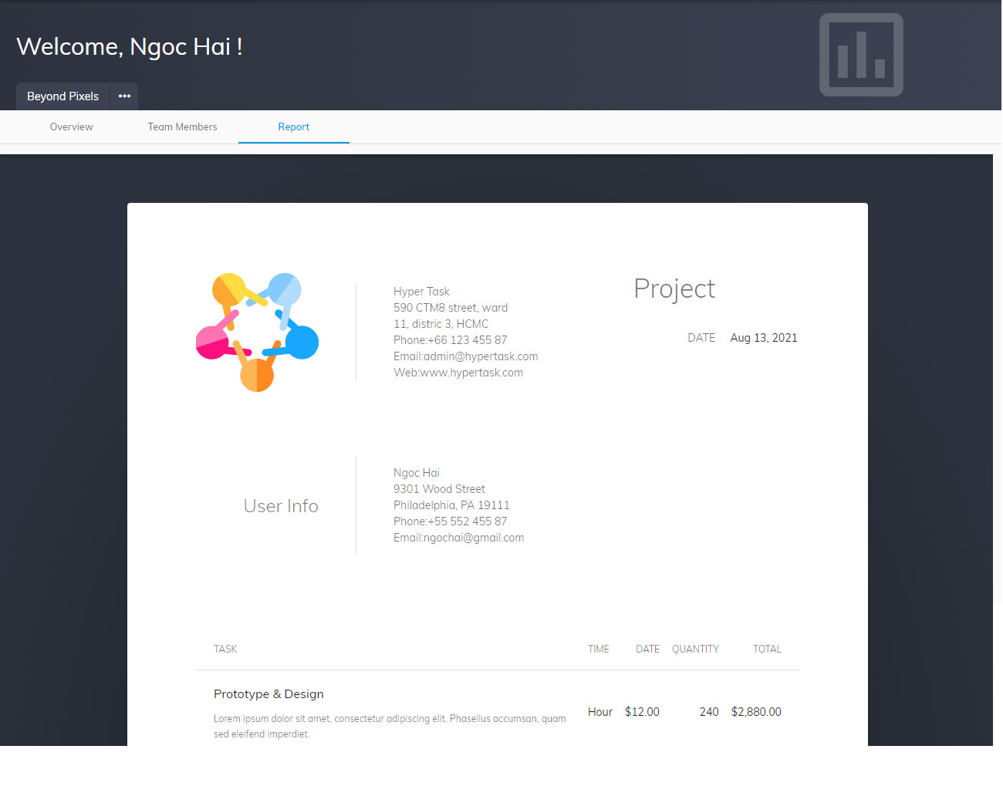

1. Report tab

# Features page

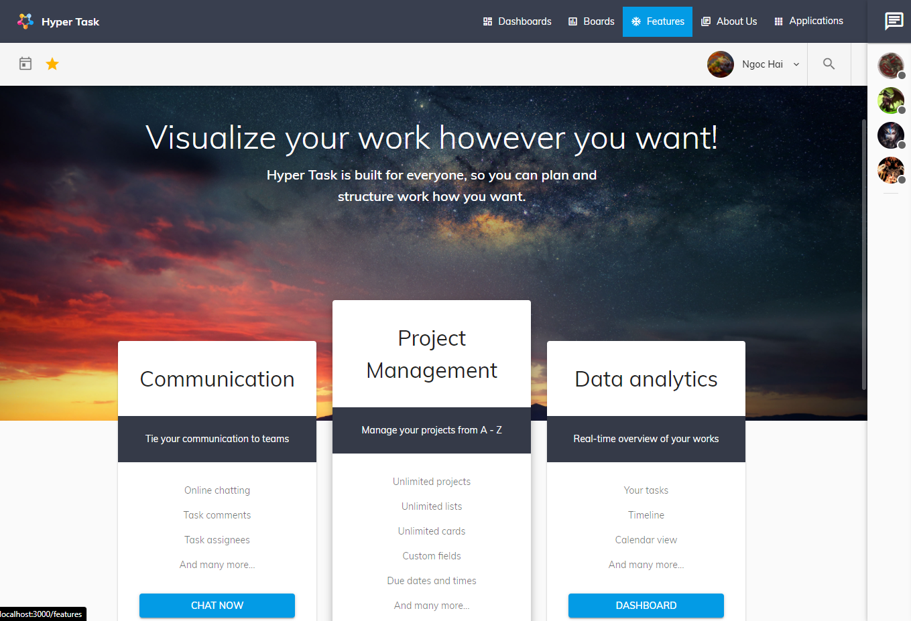

1. Feature page

Features page includes various introduction of website to give users an overview of the features and what can be done with Hyper Task

# About us

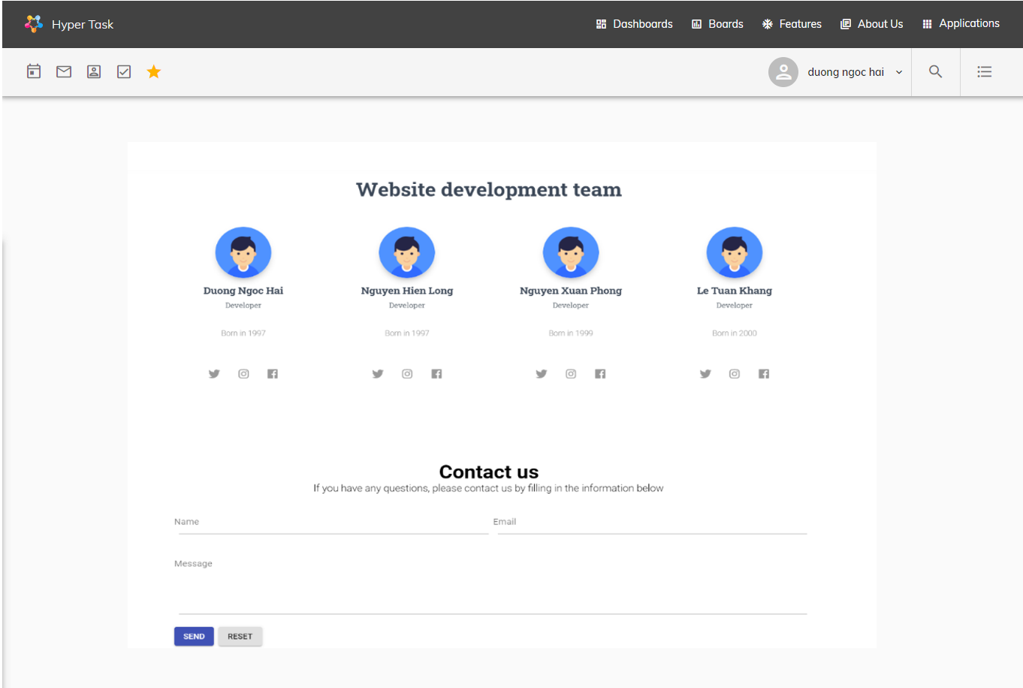

1. About us pagee

Brief information of the website’s developer team and some communication method.

# Profile page

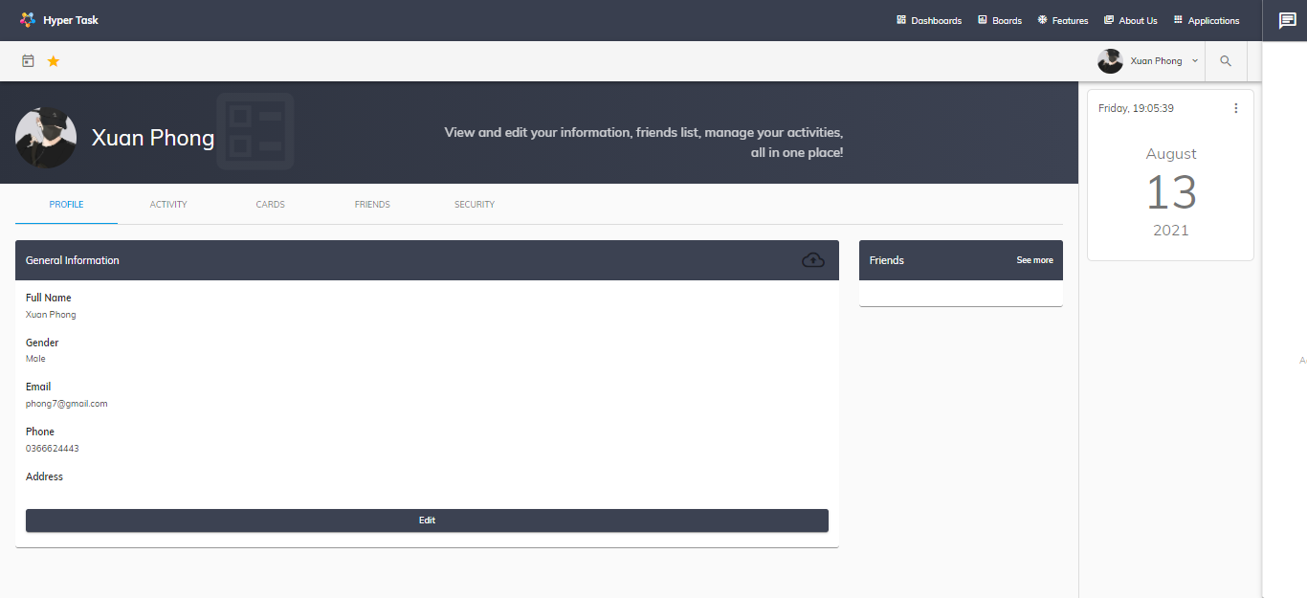

1. Profile page

Display user’s information , to get into this page user have to create account and login.

This page is used for edit user’s information.

Attention: User have to follow these rules:

|  |  |
| --- | --- |
| **Field Name** | **Rules** |
| Email | Minimum 5 characters with no special characters and not the same as registered email |
| FullName | Does not contain special characters that may contain Vietnamese letters |

To change avatar: Click upload icon in Profile page. New upload avatar dialog will open for user to select image from their PC

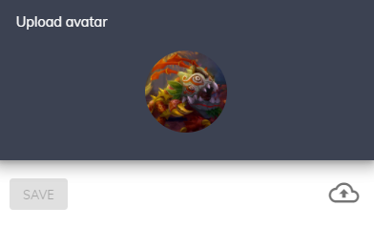

1. Upload avatar popup

# User’s activity page

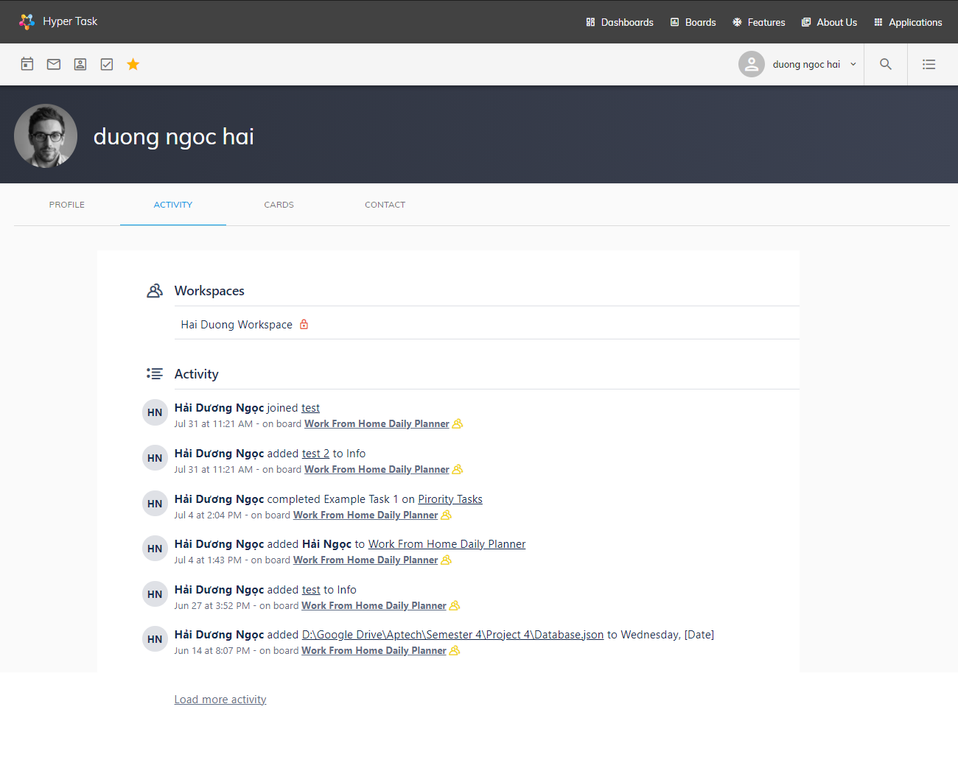

1. User activities page

This page displays a history of user activities on their boards, include many activities such as joining boards, adding, editing, deleting board data, …

# User’s card page

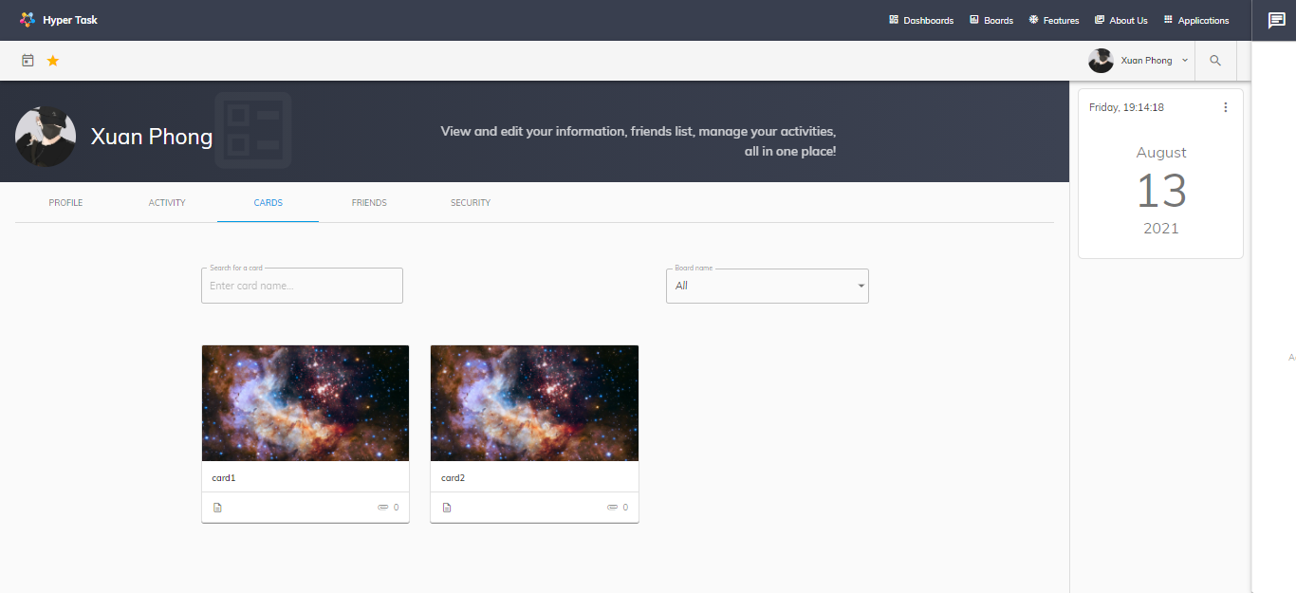

1. User activities page

Display a list of user’s card, these cards may be created by them or assigned to them, so they can track the status of them., to quickly view card on board, double click on the card to move to the corresponding board.

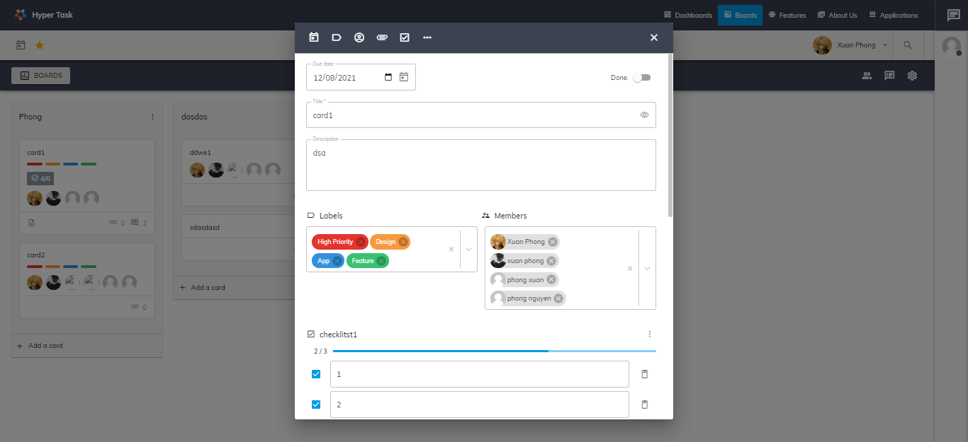

1. Card on board

# Contact page

* **Add contact tab**

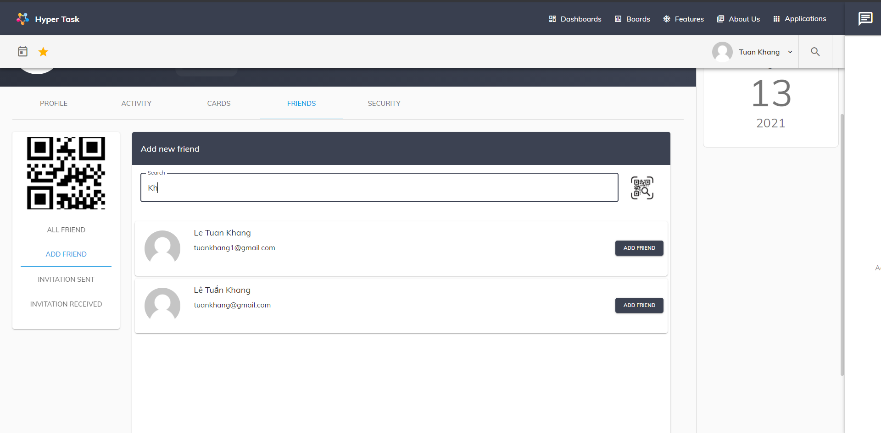

1. Add contact tab

Users can search for friends in this page by entering username or email in the search box and then clicking the Add Friend button will have a message that the request has been successfully sent.

Or users can search by QR code by clicking on the QR code icon

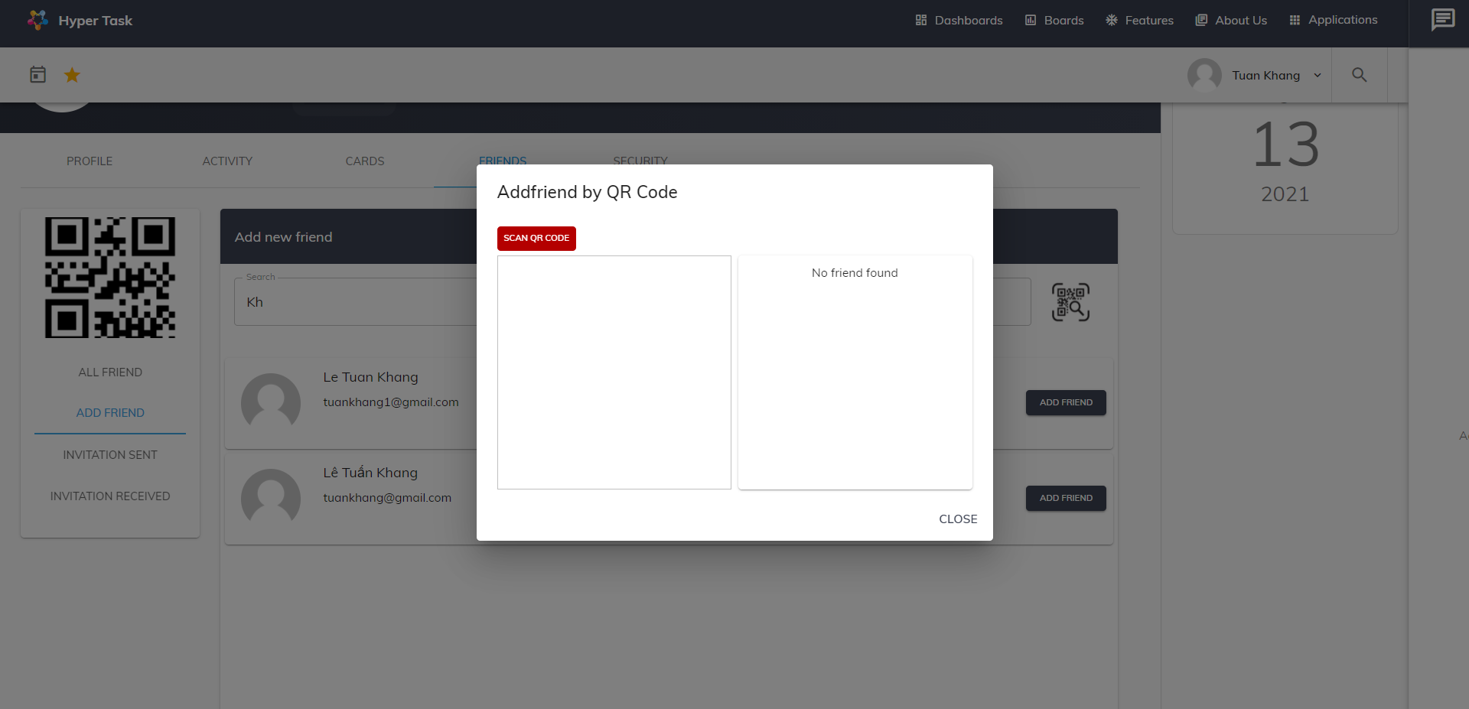

1. QR code scan #1

Click Scan QR Code button and choose QR code image

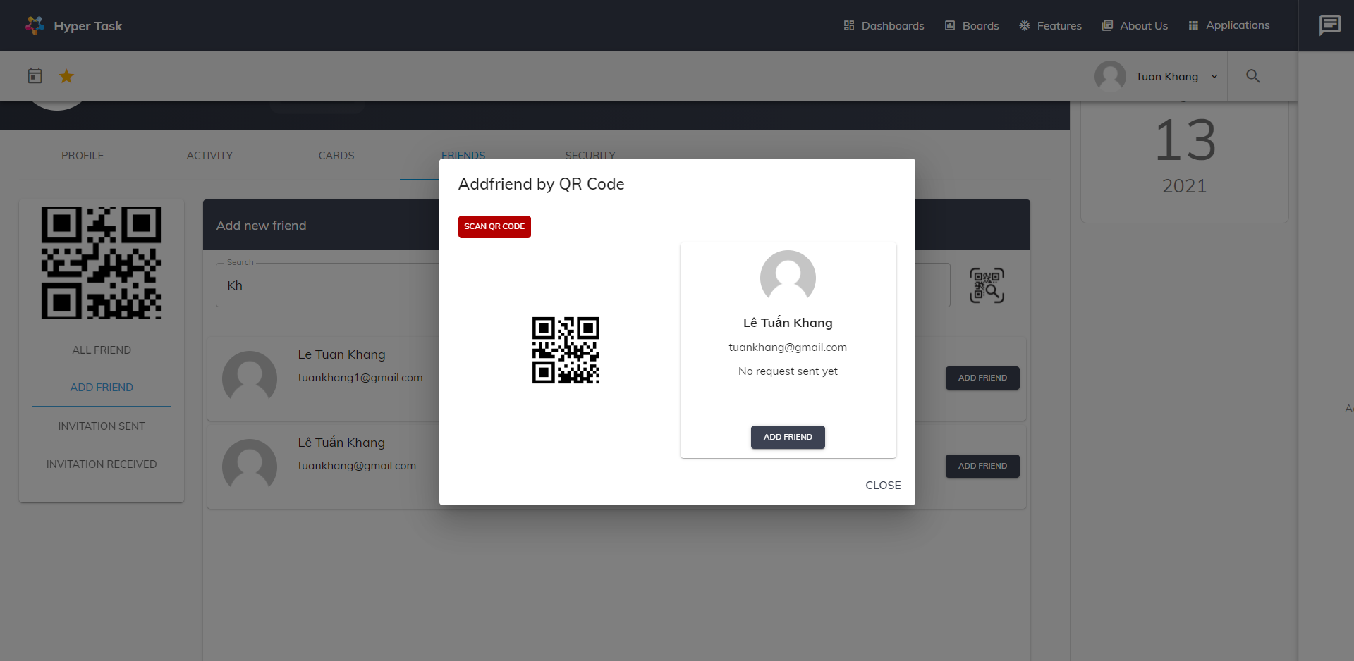

1. QR code scan #2

Information about the person you are looking for will be displayed

* **Sent invitation tab**

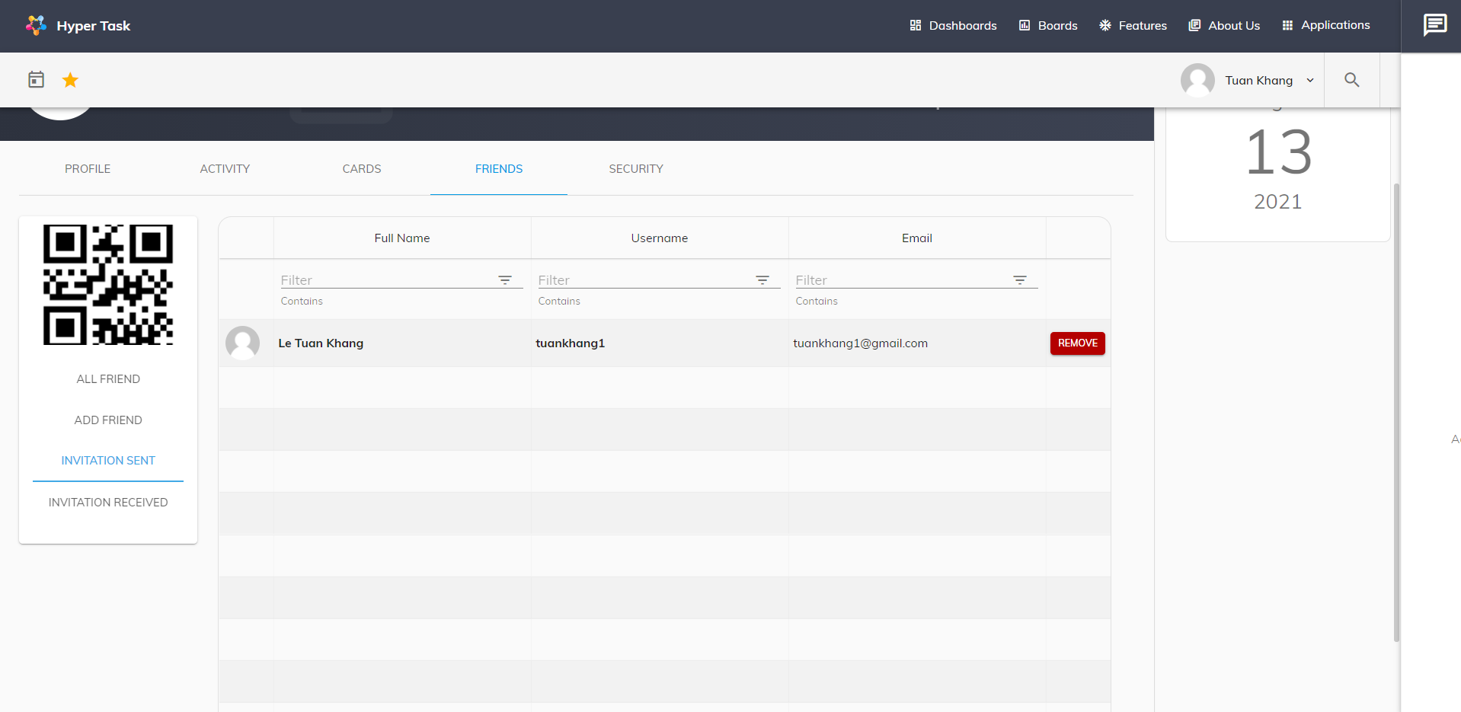

1. Sent invitation tab

Here displays a list of friend requests sent by the user. User can cancel the friend request by clicking on the button.

* Received invitation

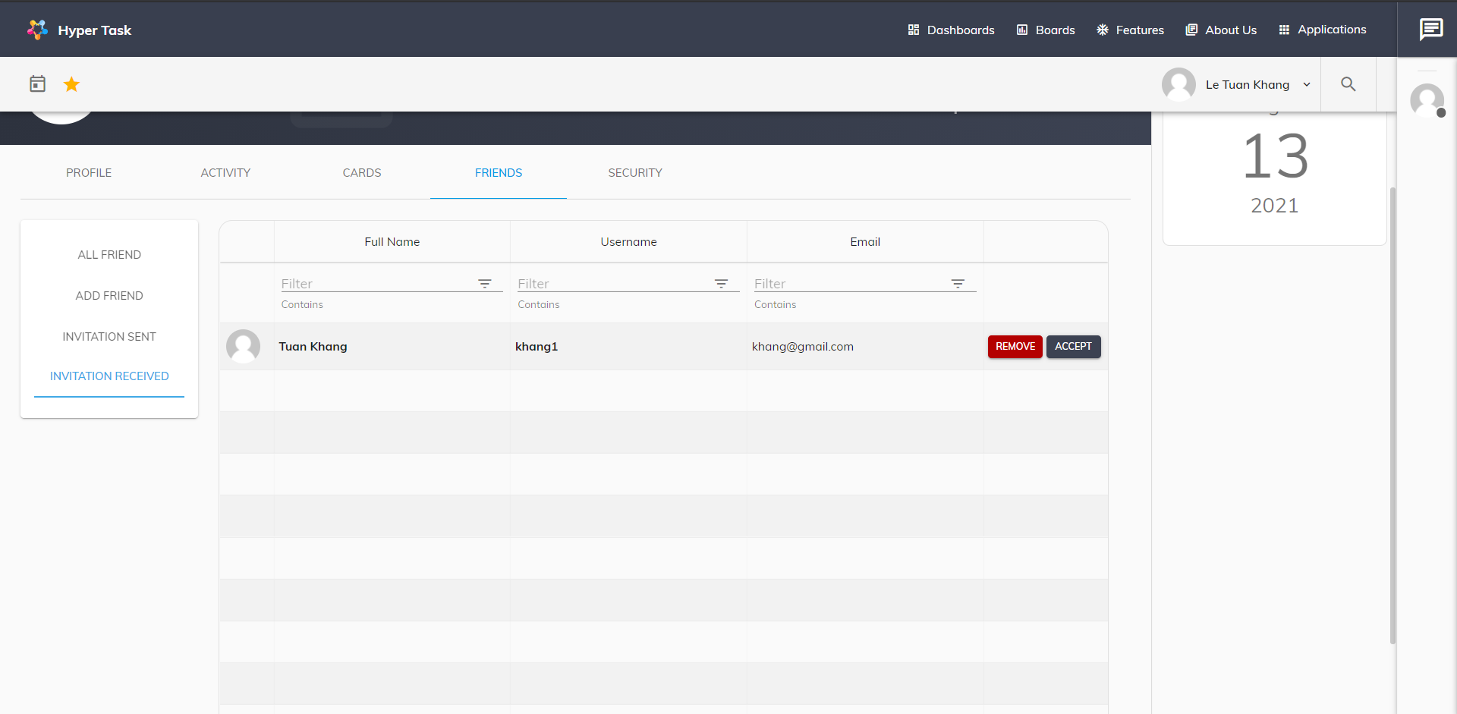

1. Received invitation

Here you can accept or remove invitations received from others

* **Contact Tab**

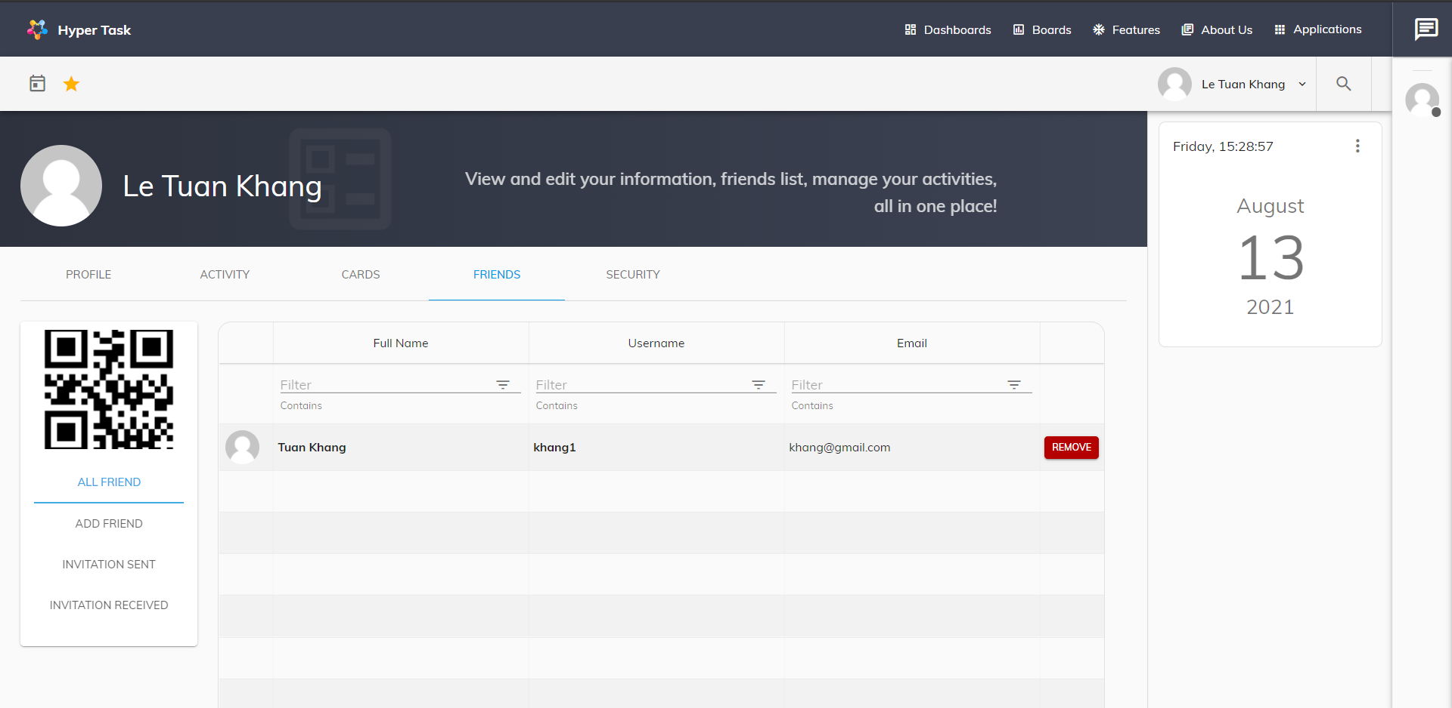

1. Contact tab

Friend tab shows all of the user's friends, Users can delete friends in this tab

# Change password page

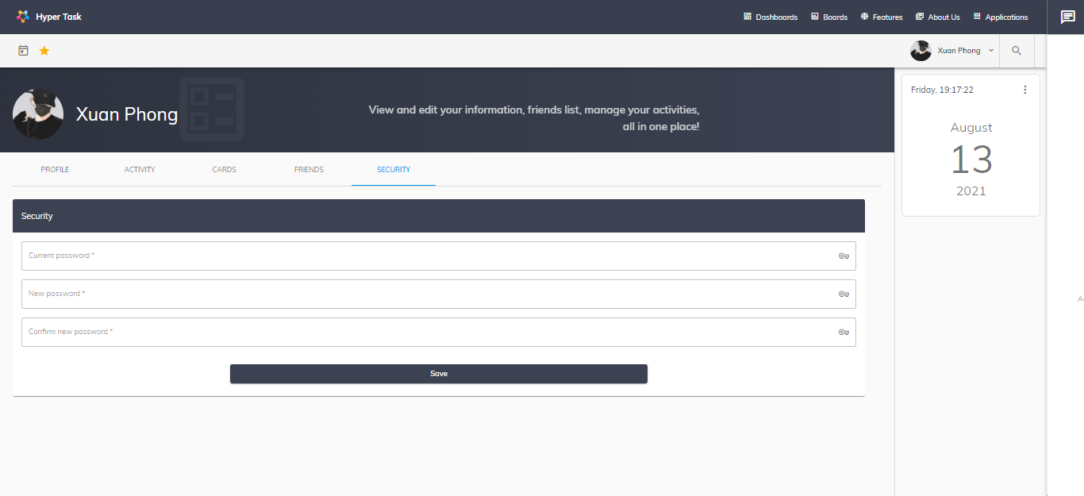

1. Change password page

User can change their password here.

Attention: User have to follow these rules:

|  |  |
| --- | --- |
| **Field Name** | **Rules** |
| Old Password | Required, must match with their curent password |
| New Password | Required, at least 6 values |
| Confirm New Password | Required, match with New Password |

# Boards page

Organize work like sticky notes and track tasks through every stage. Boards help make your work processes more transparent.

Containts below features:

* Search Board: user can search for their board
* Follow Board: user can watch/delete all their followed boards
* Boards List: user can watch/delete all board they created and assigned
* Add Board: user can create their new board
* When click board, user will be lead to a single board working area:
  + Board: User can edit name, background, add to followed boards
  + List: User can create/edit/delete working list and create card
  + Card: User can edit/delete working card

Add Member: User can add more member to this board

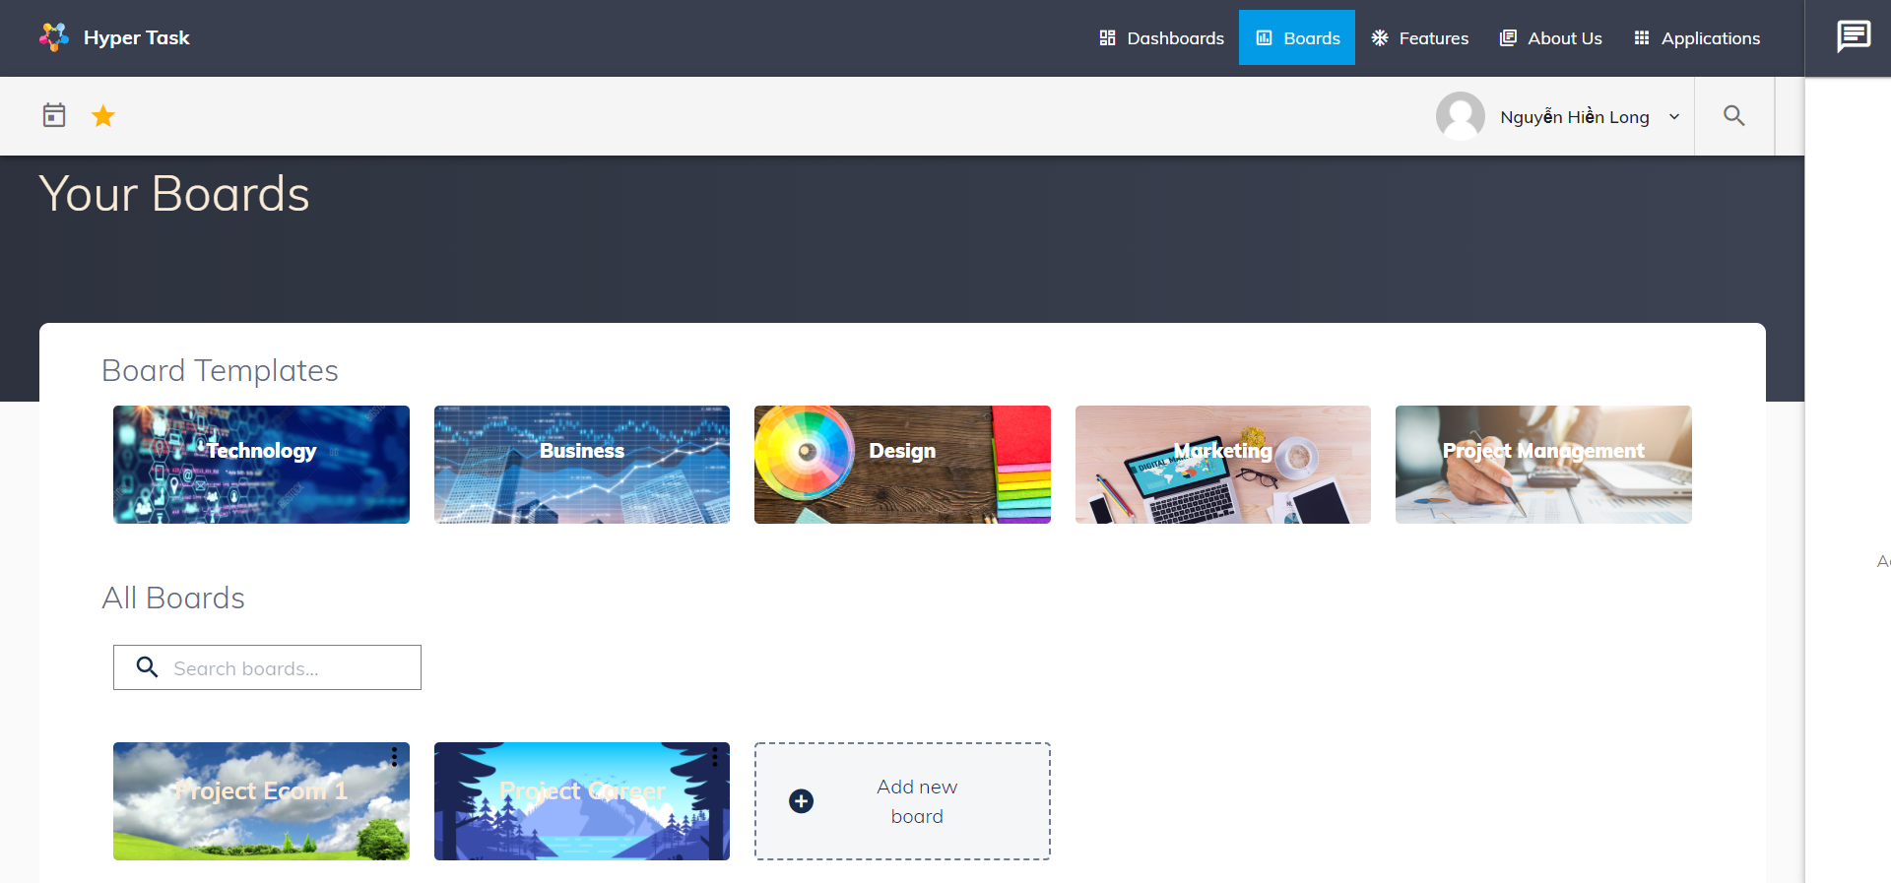

1. Boards page

User can create or delete board in this page. To create board, user can click to Add new board or click to board template categories.

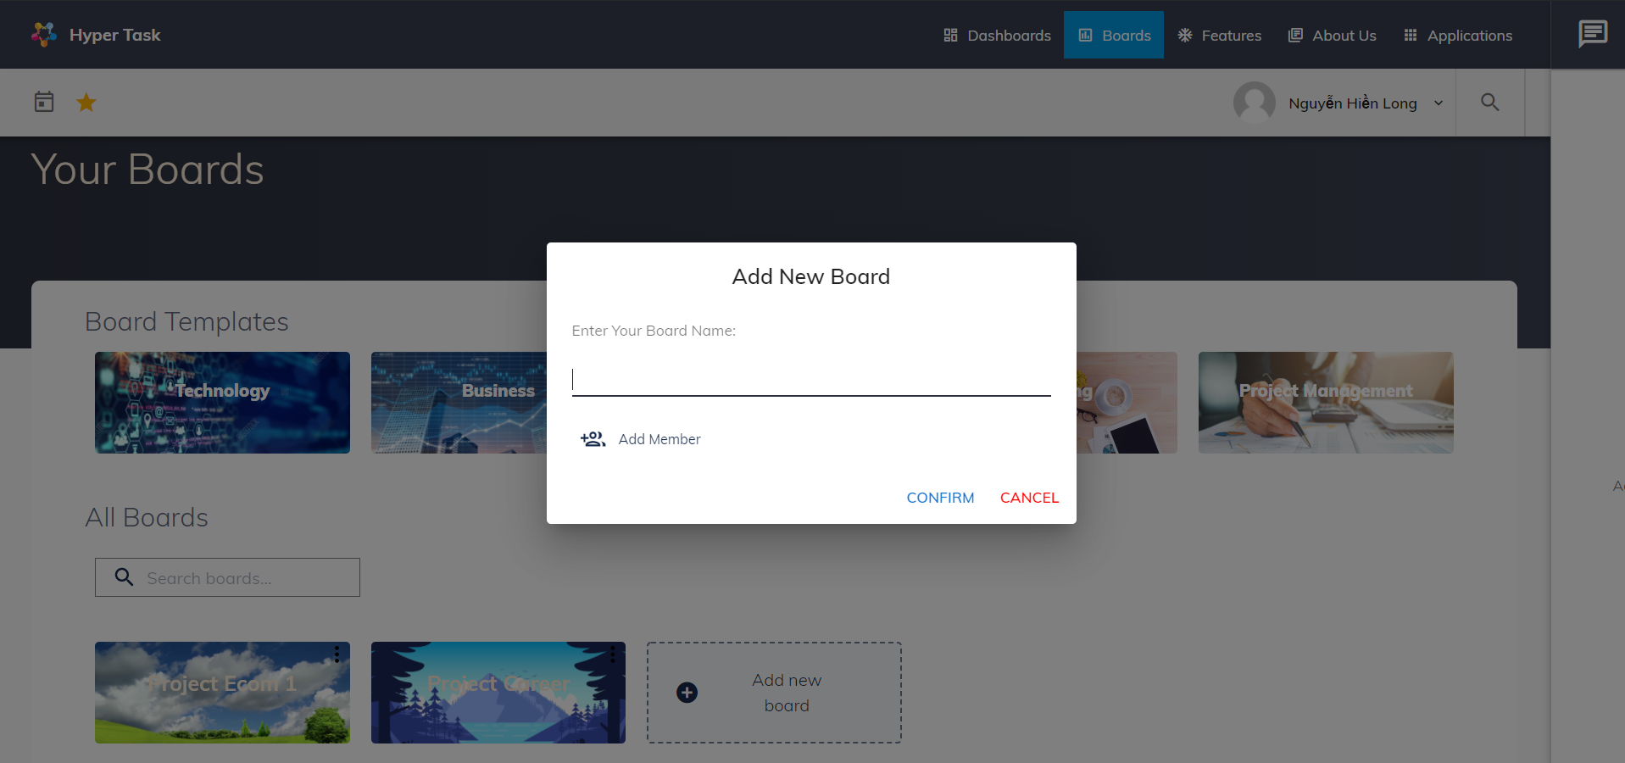

1. Create new boards

User can set board name and board member in creating new board, or skip it and new board will have default name and no member.

# Board details page

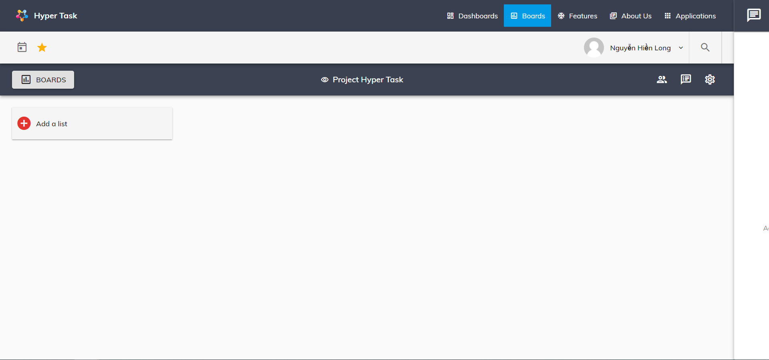

1. New created board

After create board, user will be redirected to board detail page. In this board user can edit board, create list and create card base on what user want.

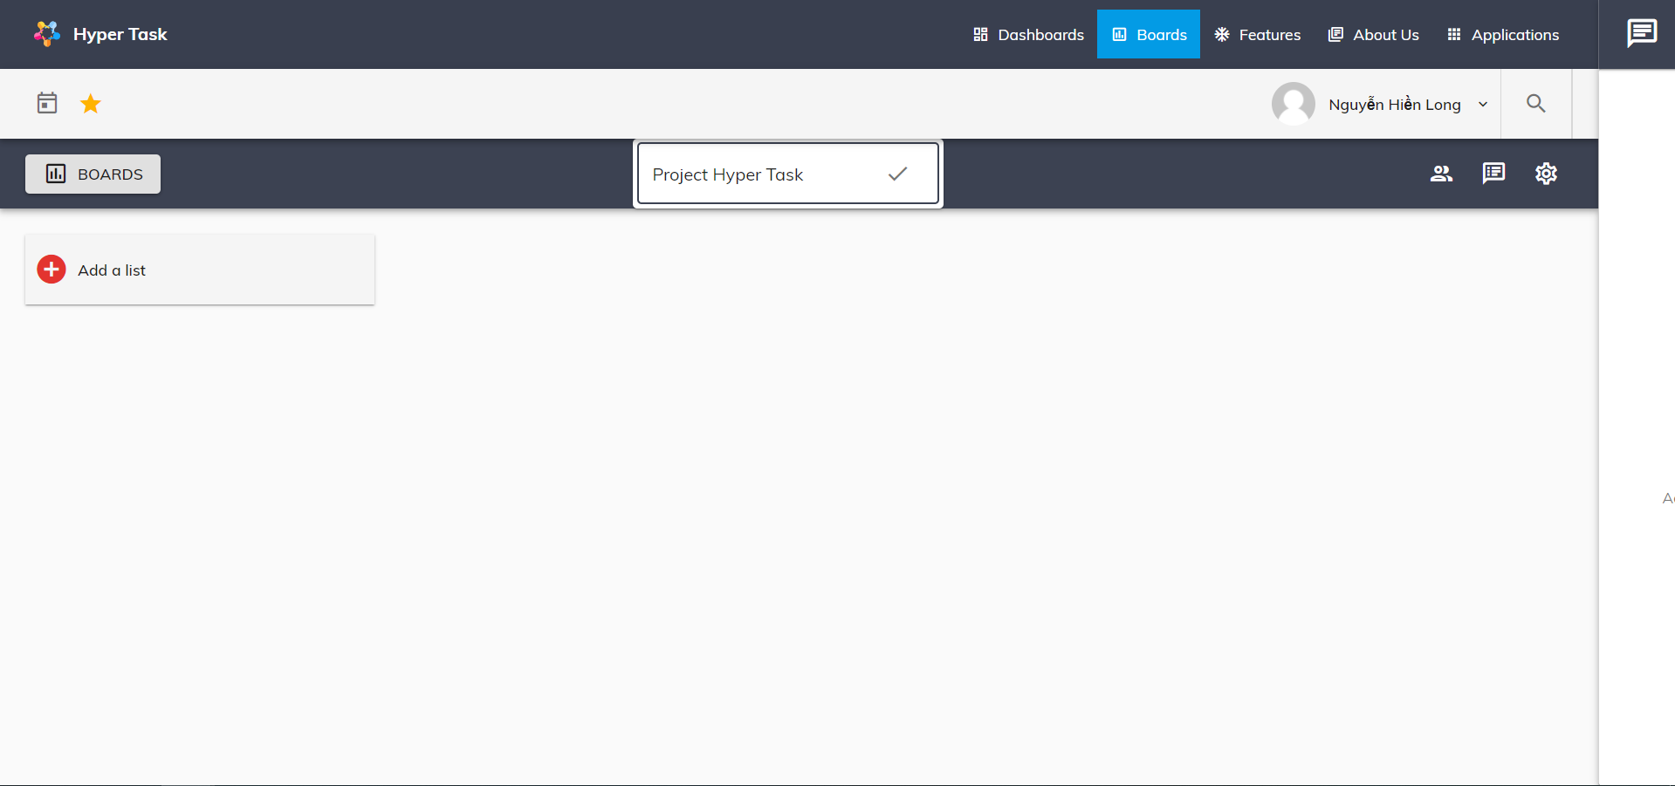

1. Rename board

To rename board, user can click to board name and rename it.

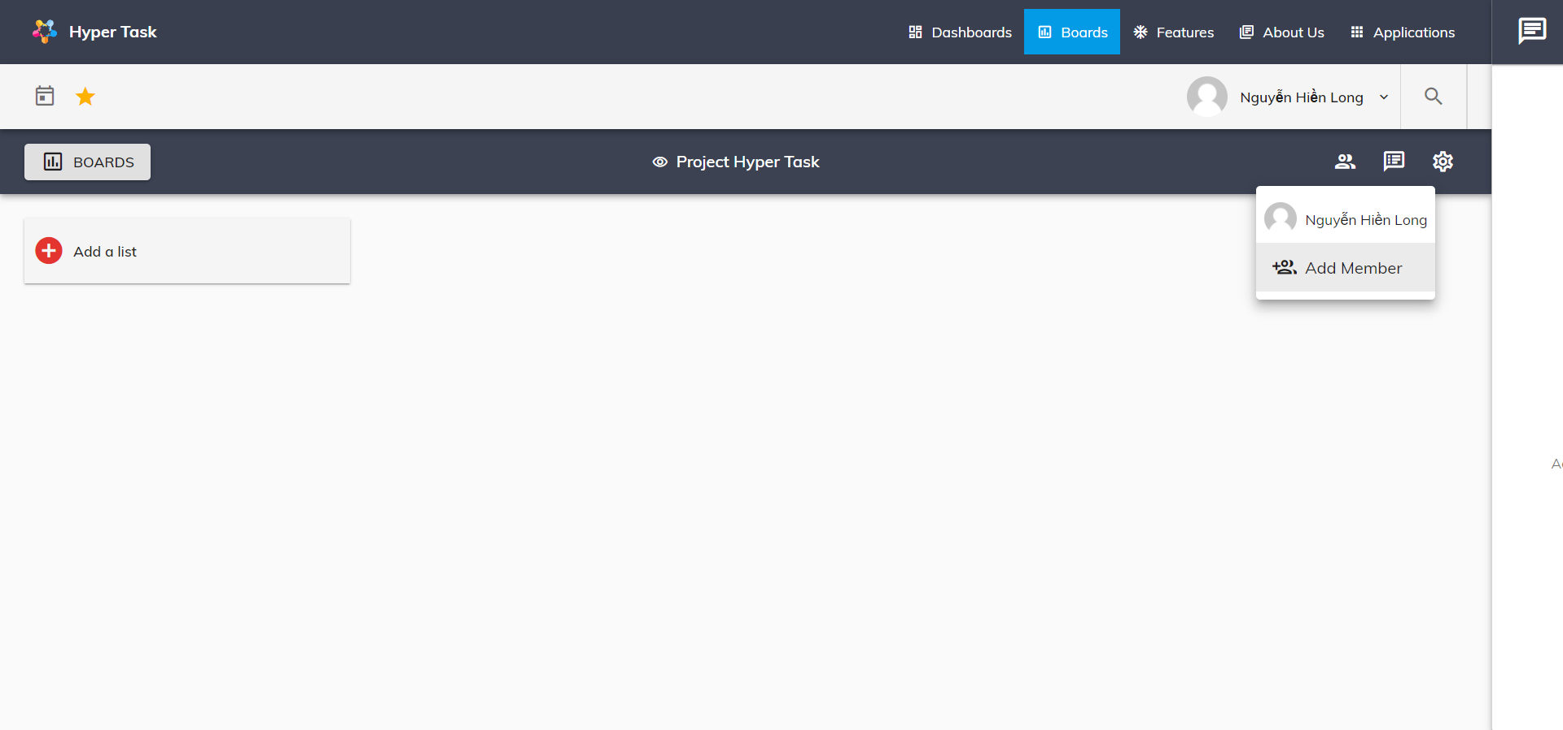

1. Add member to board

To view board member and add member, user can click to member icon to view and click to Add Member to add new member.

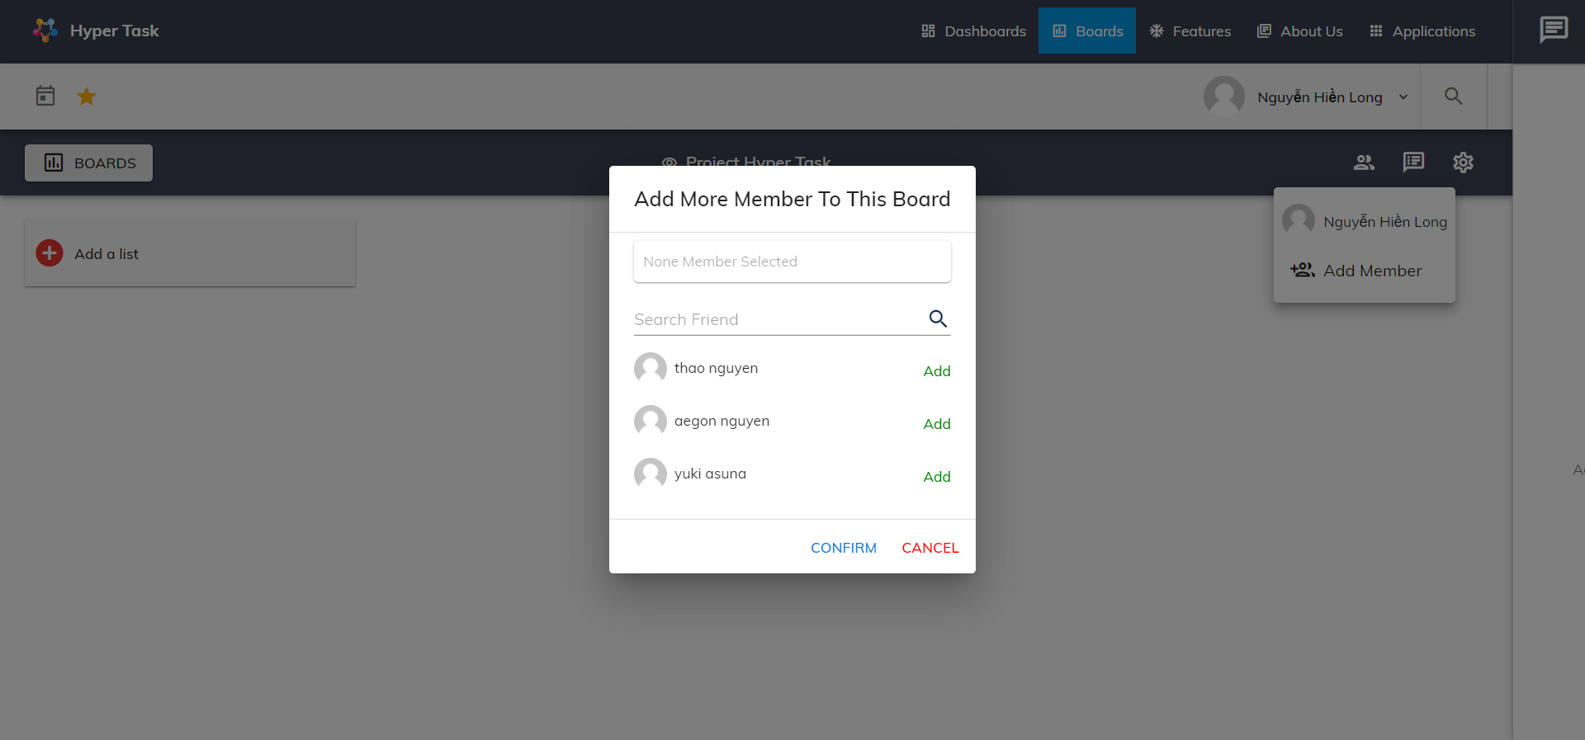

1. Search all user

User can search member in search field and click Add and Confirm to add new member to this board

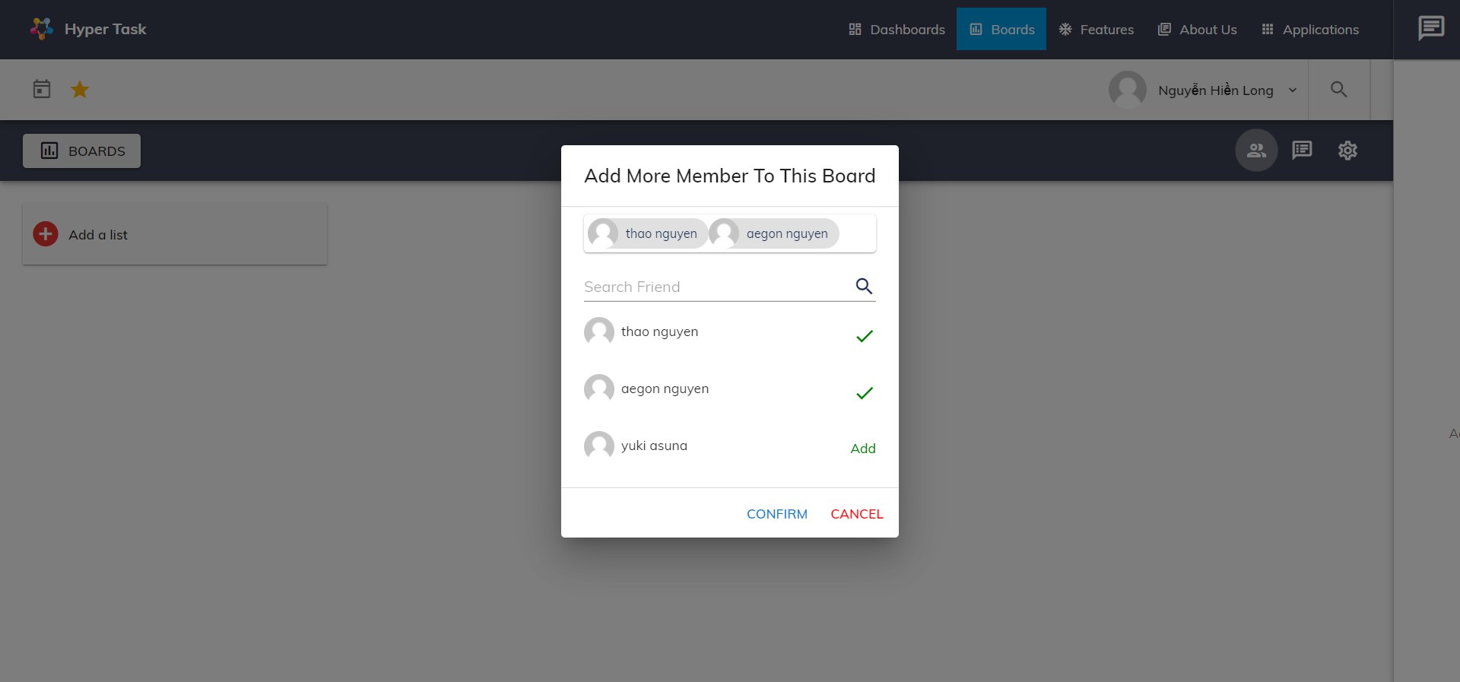

1. Add user to board

To view board activities, user can click to activity icon.

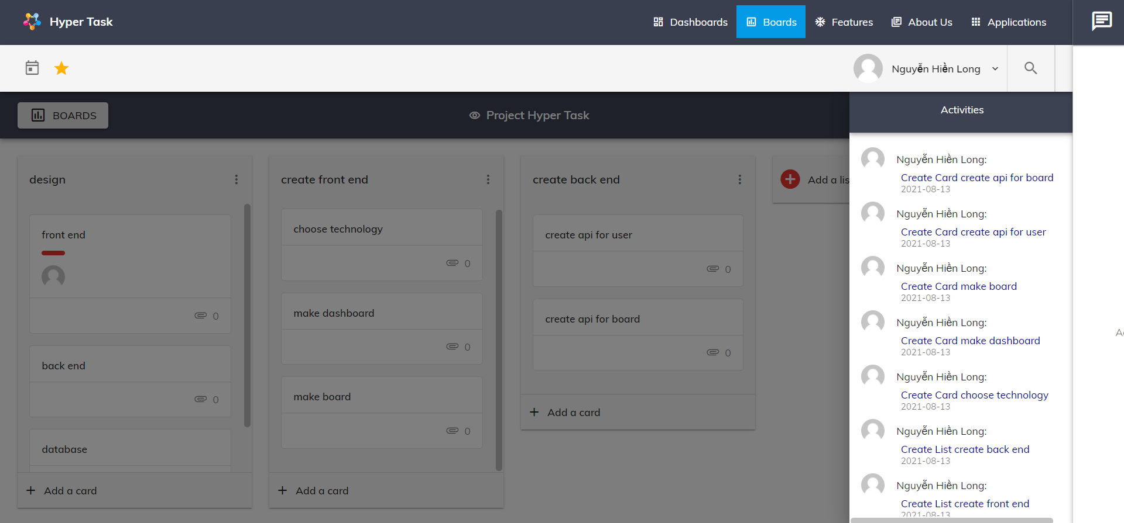

1. Board activities

User can change setting board by click on setting icon

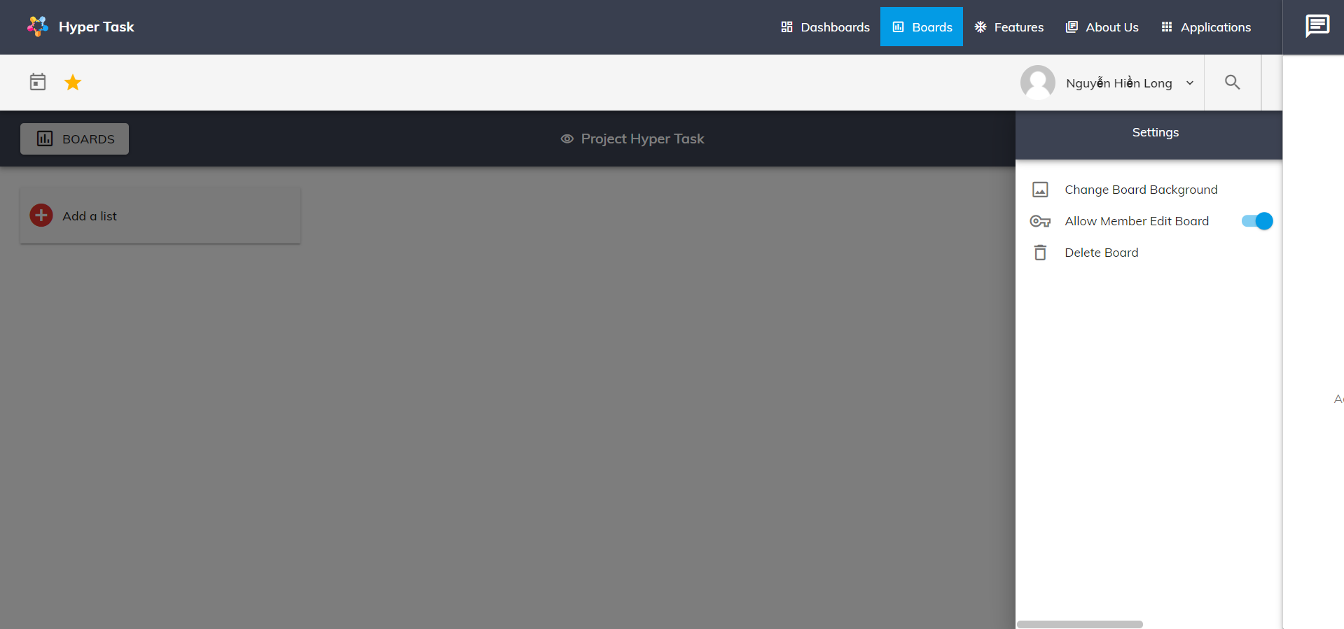

1. Board setting

User can change board background by click on Change Board background

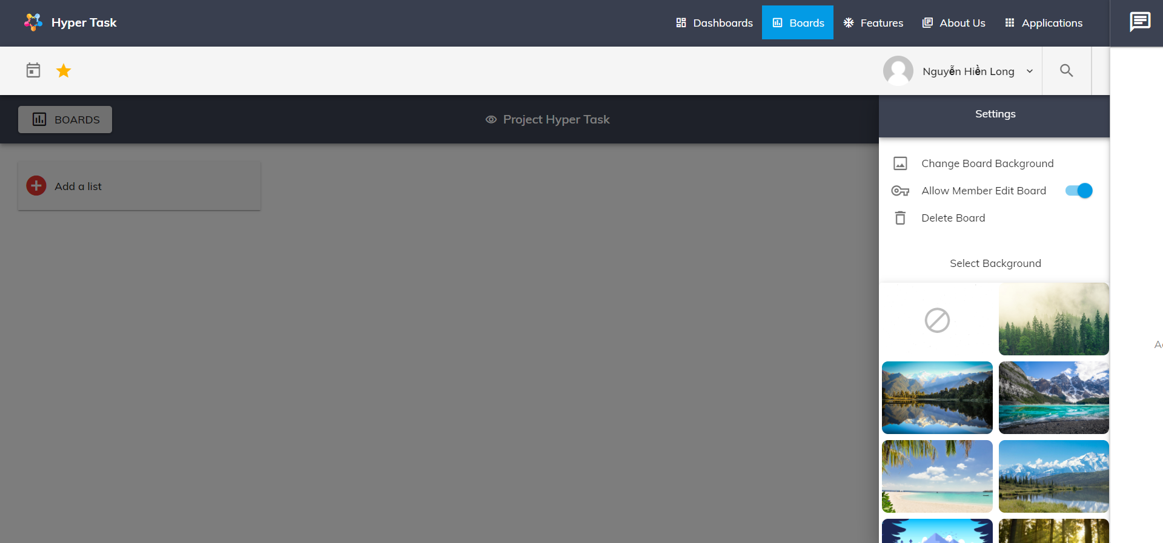

1. Board background select

After that user can choose what background image they want.

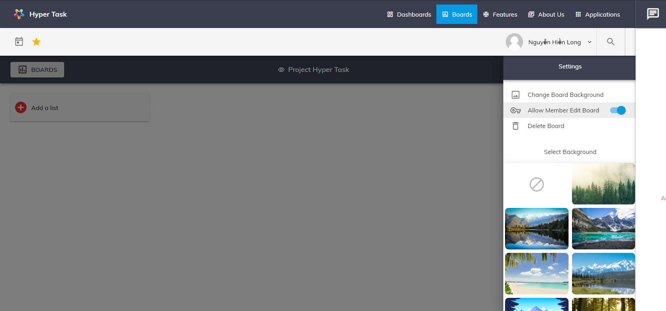

1. Allow user to edit board

User can allow board member can edit this board or not. This function only available for admin (the one create this board).

* List

To create new list, user can click to Add a list button, then add list name and click button ADD to create new list.

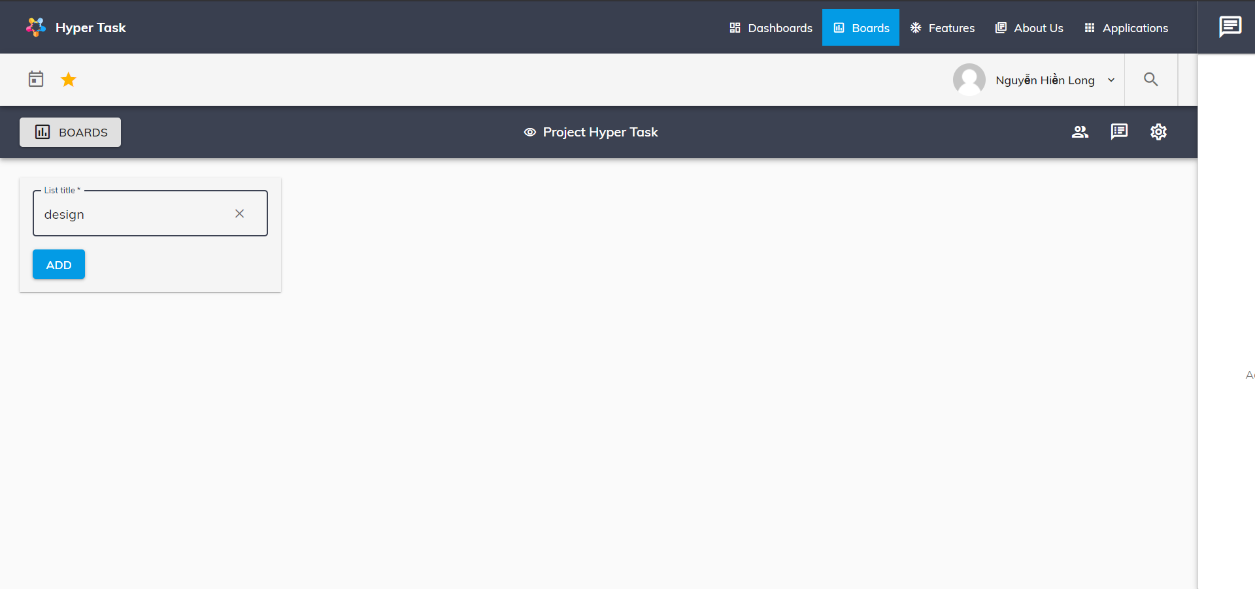

1. Create a list

User can rename or remove list by click on setting list icon

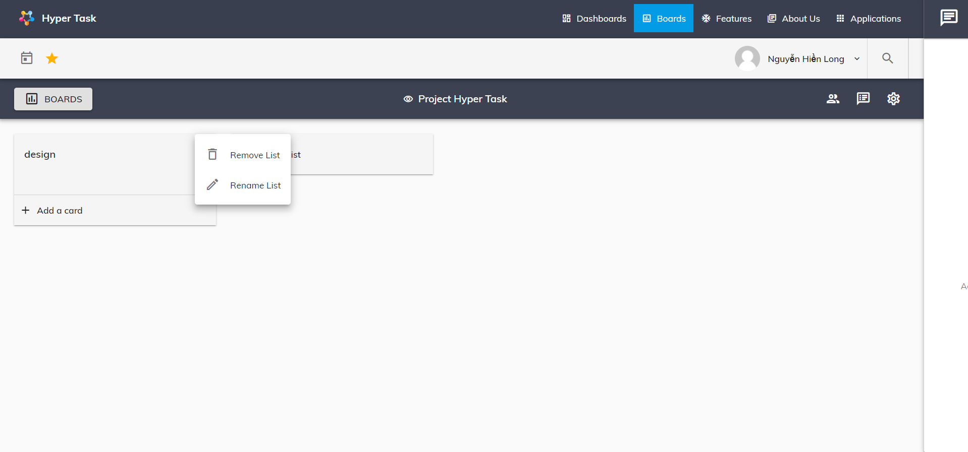

1. Edit list name

* Card

To add new card, user can click to button Add a card and add card name to text box and click button ADD.

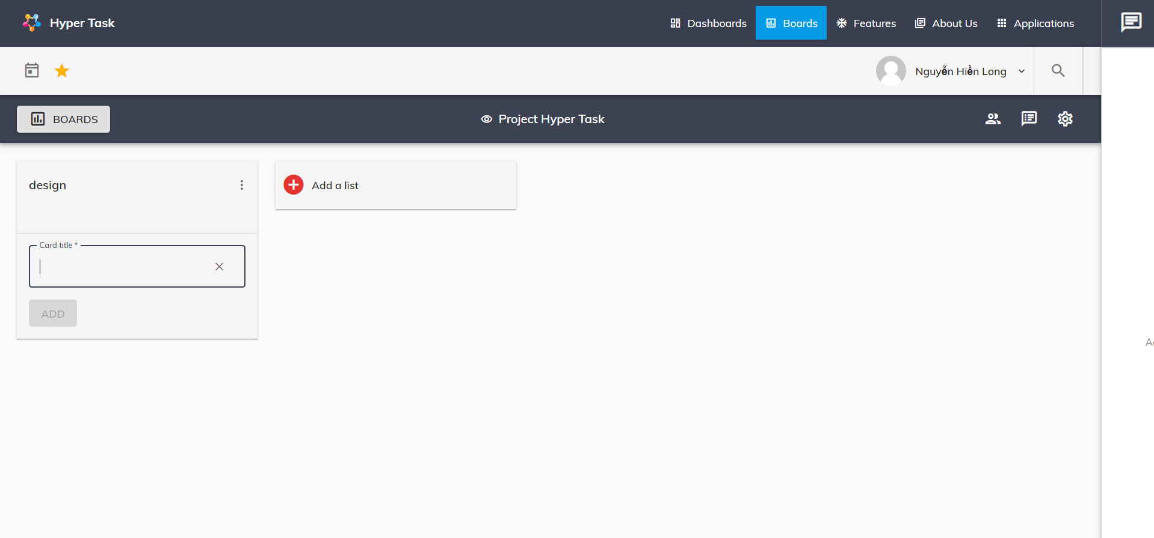

1. Add card

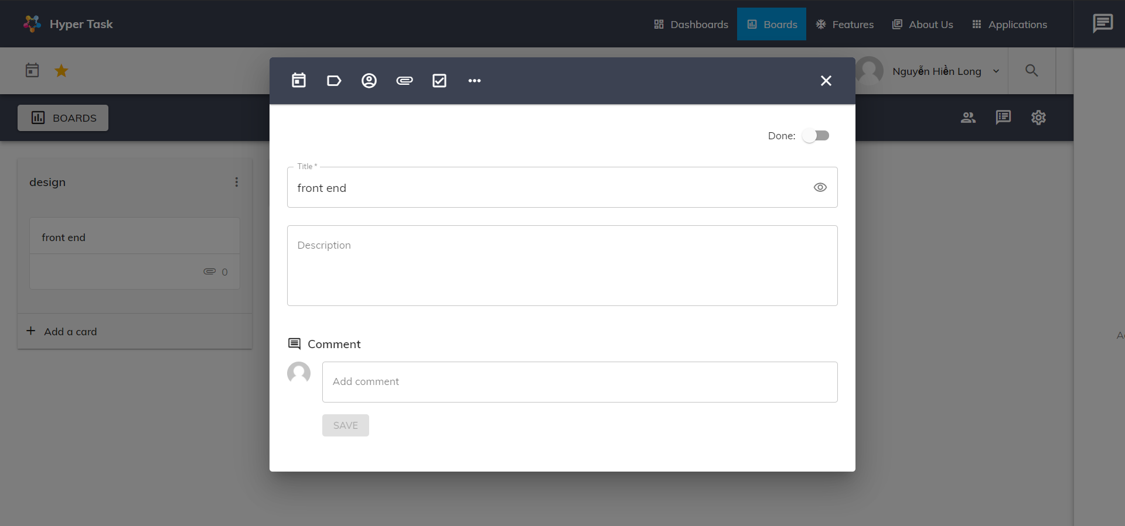

1. Card detail dialog

To edit card, user cand click to card and edit it. User can edit card name, card description, add date, add label, add member, add attachment, add check list, add comment, check card done or delete card.

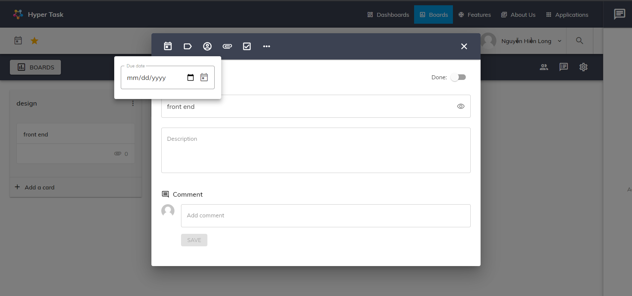

1. Add date to card

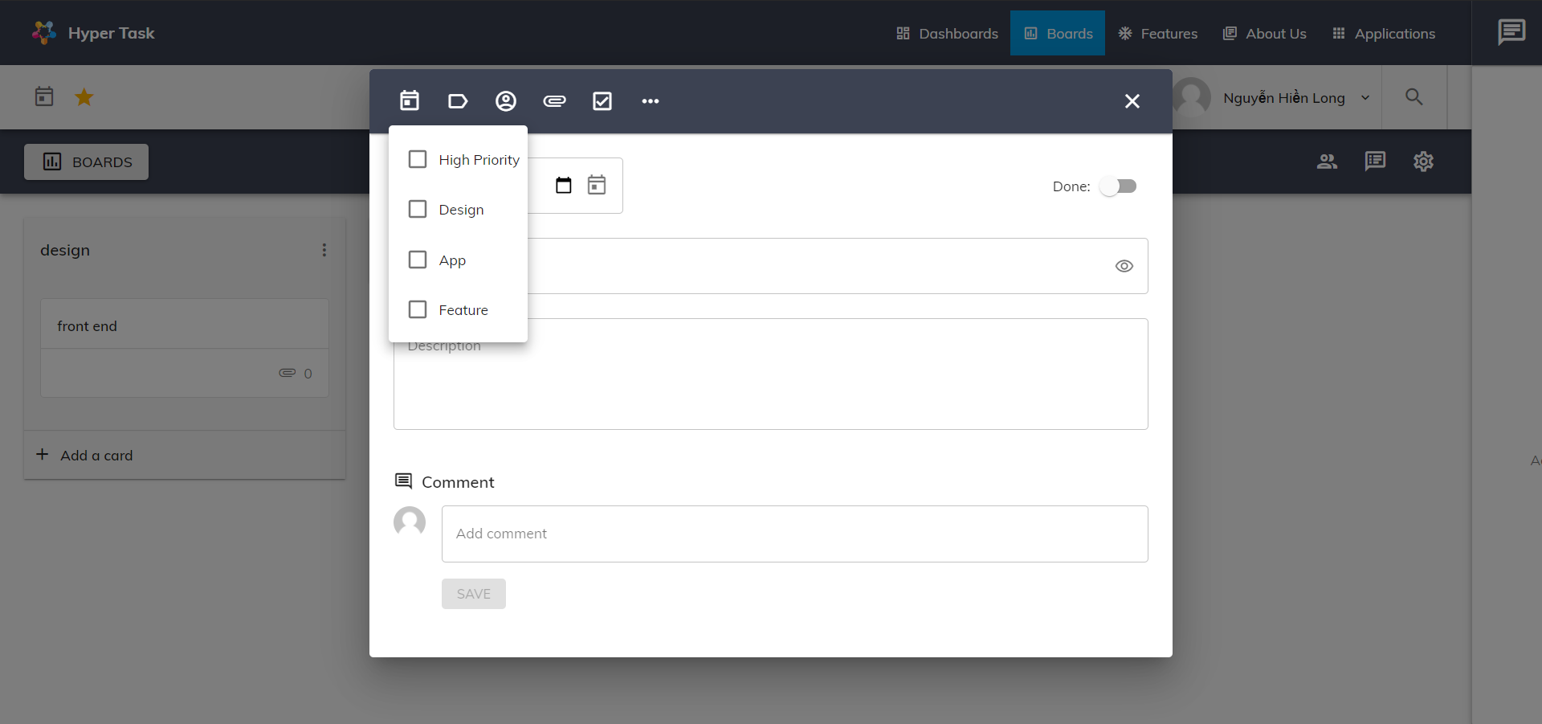

1. Add label to card

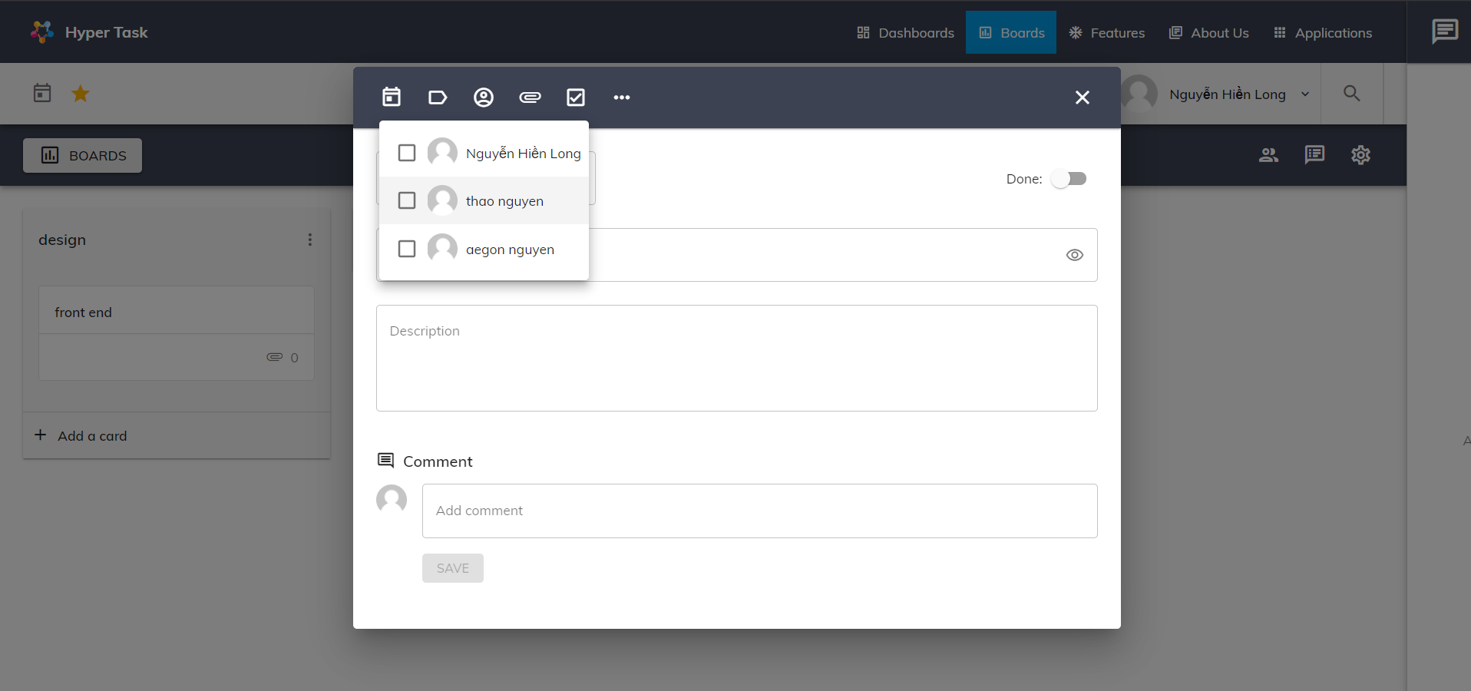

1. Add member to card

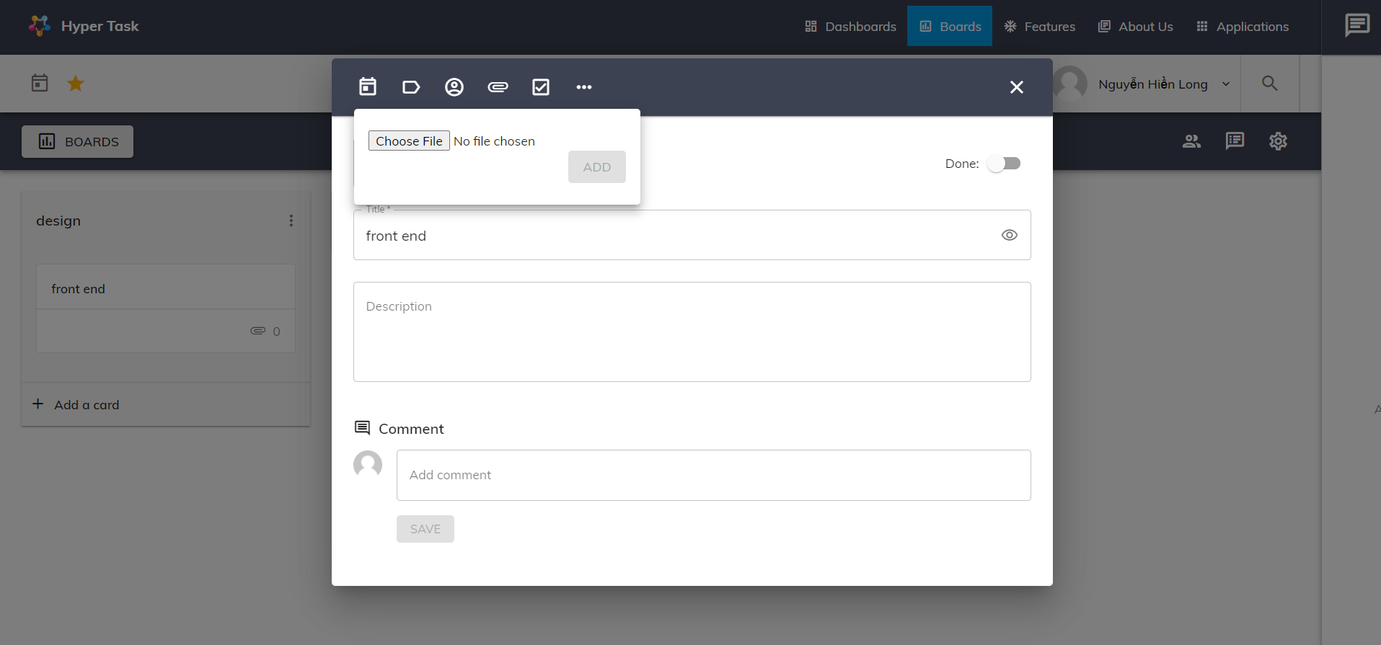

1. Add attachment to card

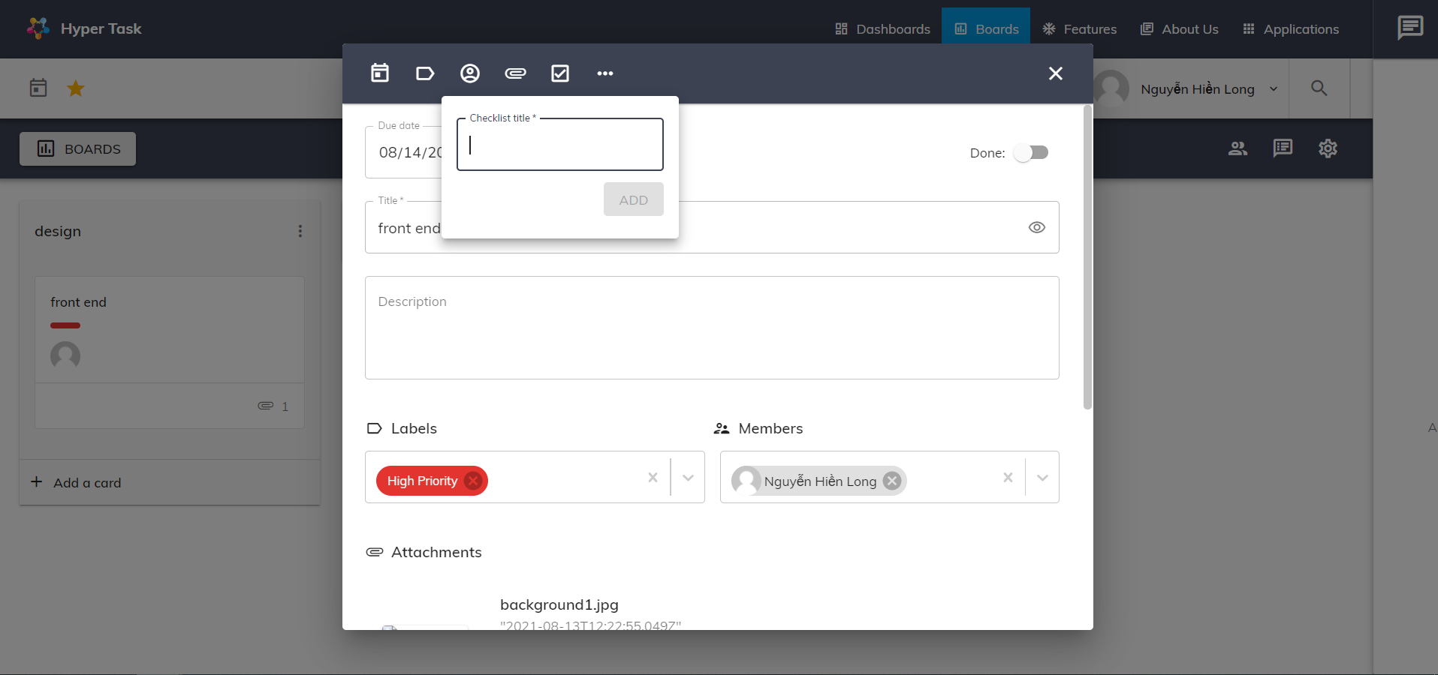

1. Add check list to card

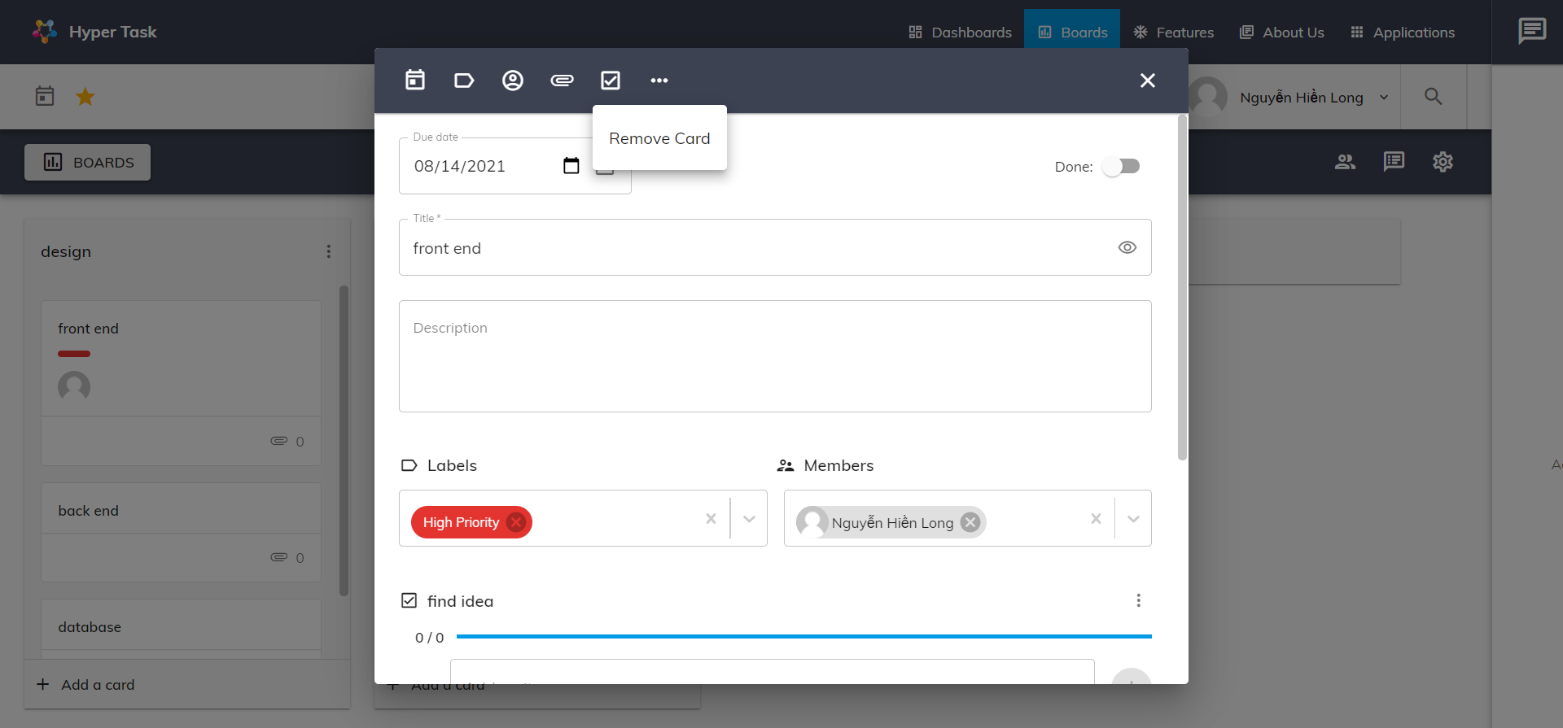

1. Remove card

User can reorder list by drag a list and drop it to specific place

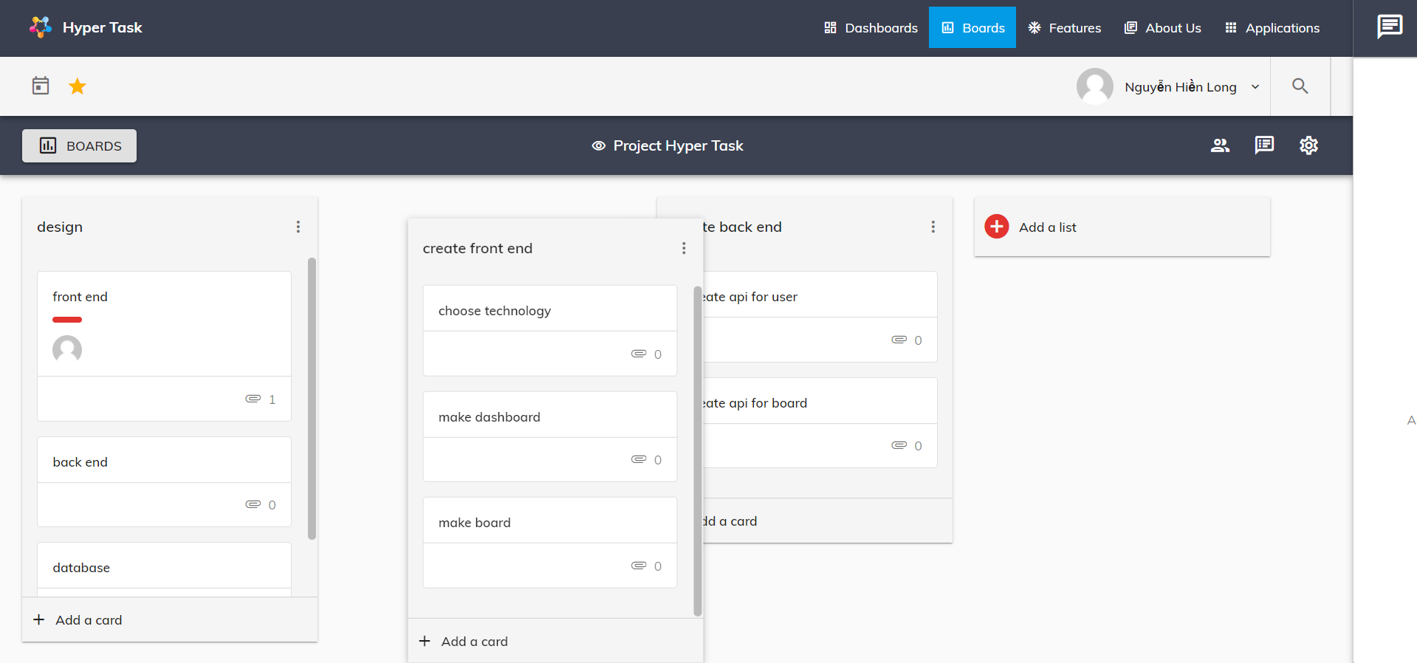

1. Order list

User can reorder card by drag a card and drop it to specific place

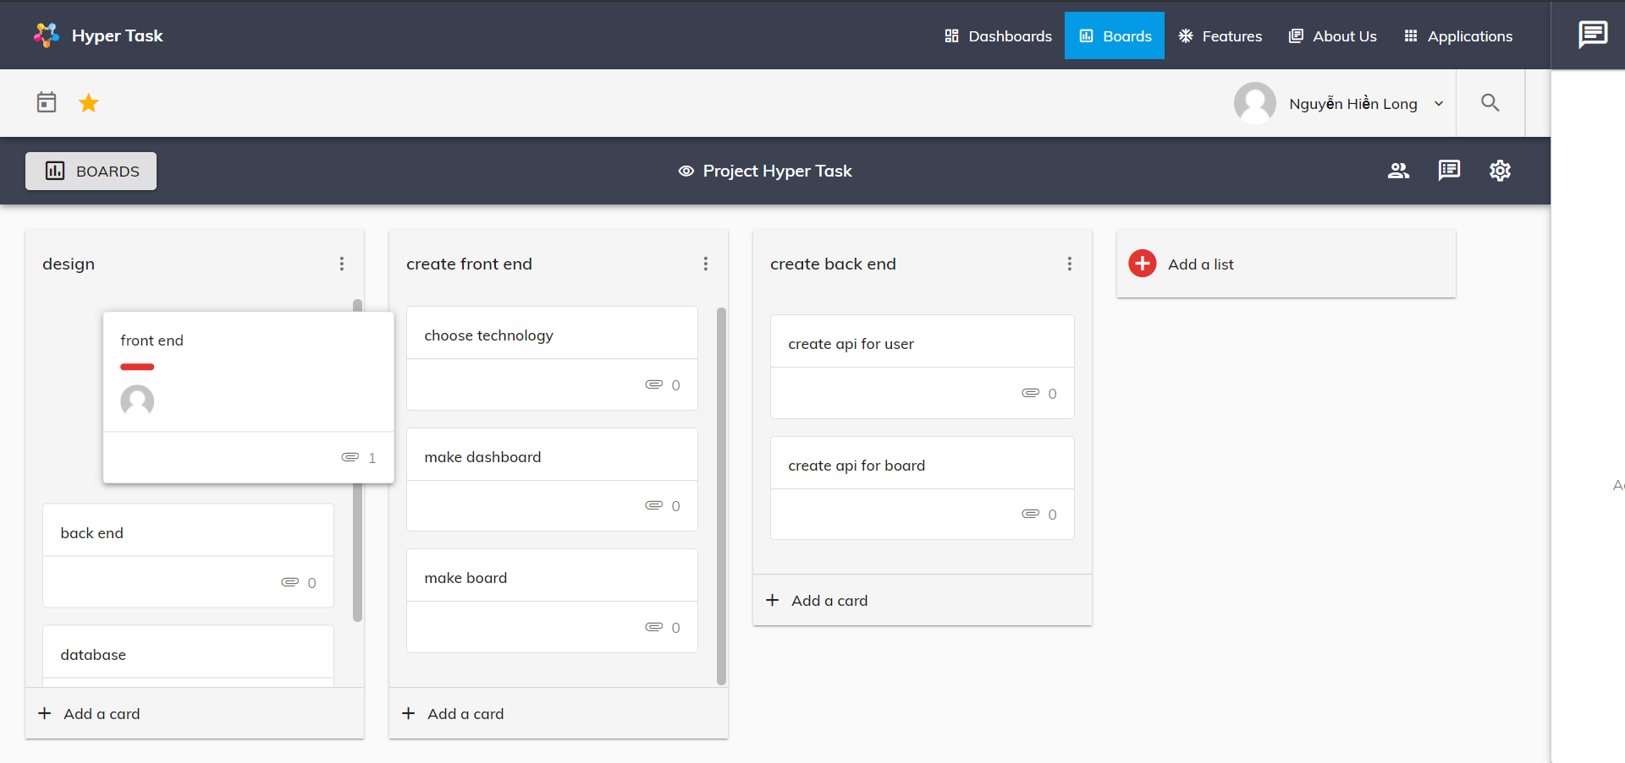

1. Order card

# Chat component

User can chatting online with their contact, when an user online, the status dot will go green, this component is attached to all page of website.

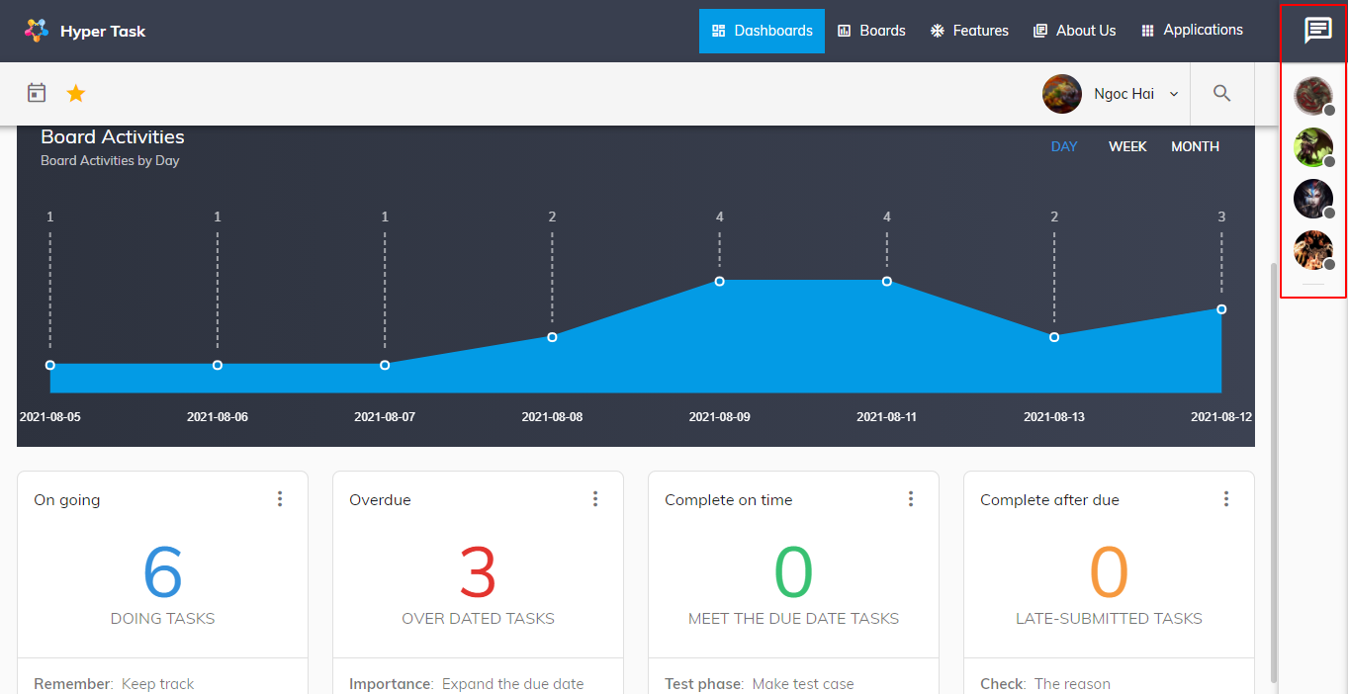

1. Chat side bar

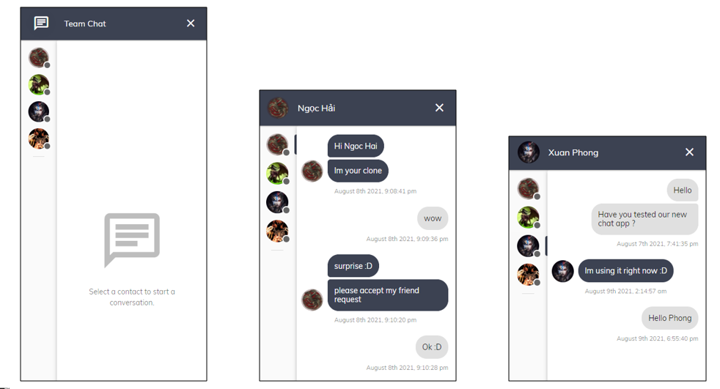

1. Chat panel

# Note page

User can use to write important things, add label for them for filter…

* Create note: Click “Take a note” in note page default. Fill in the information and click create

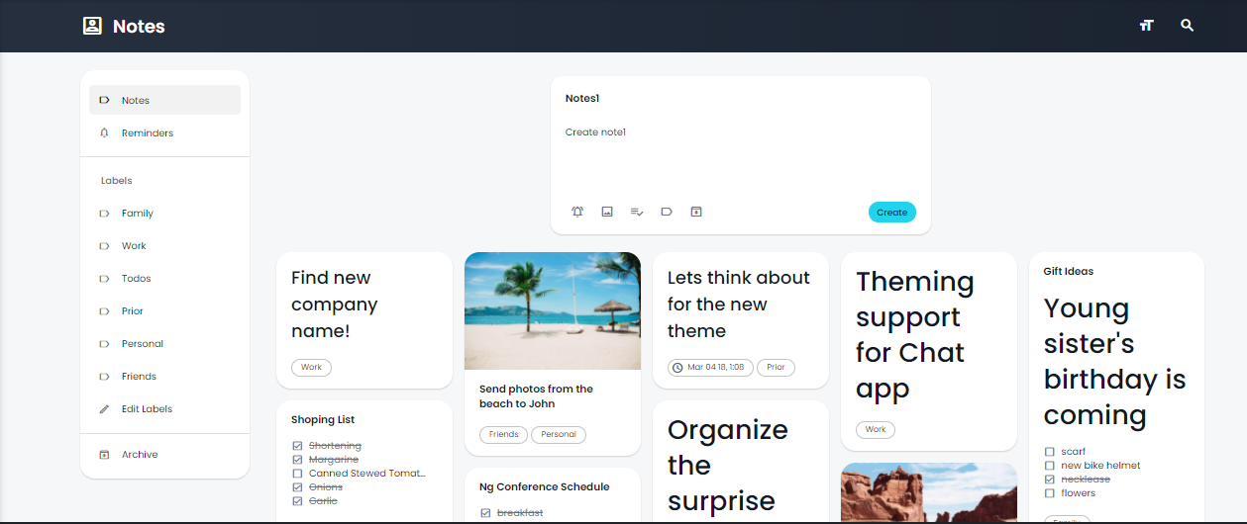

1. Note page

* Edit note: click card note. Fill in the information and note will be update real time

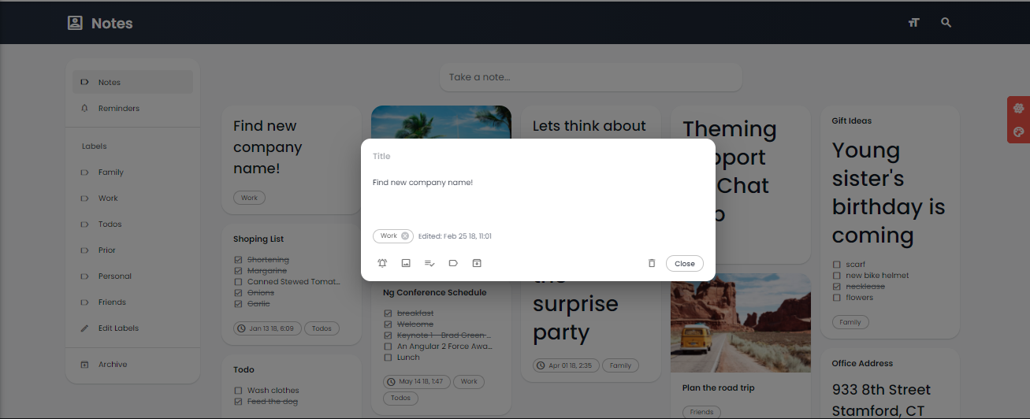

1. Create new note

* Create, edit, remove Labels: Click “Edit Labels” and Create, edit, remove labels here

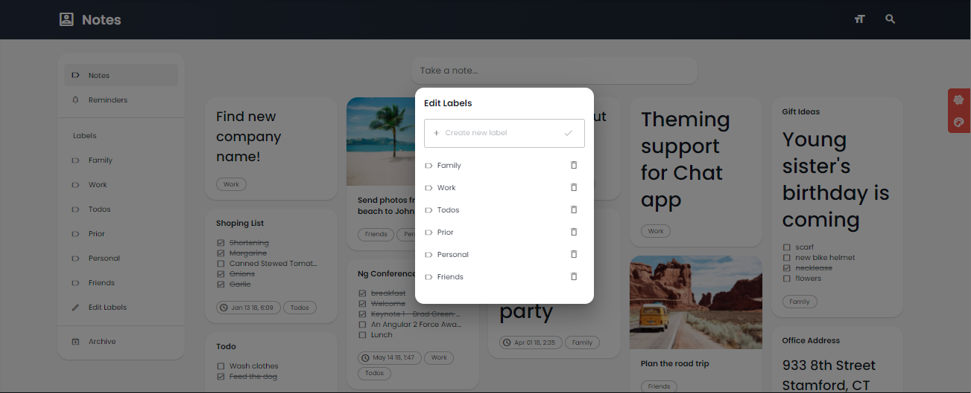

1. Modify note labels

# Calendar page

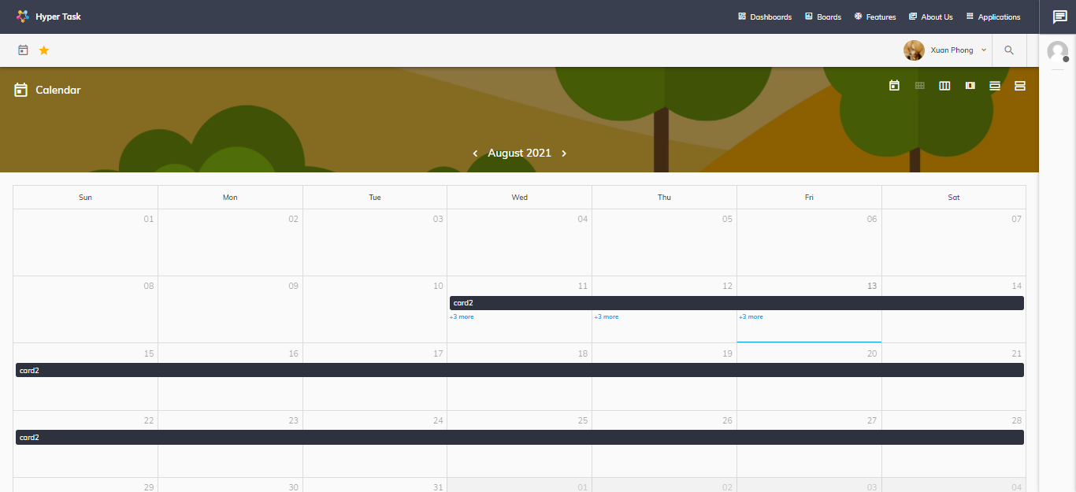

1. Calendar page

Calendar page: User can view calendar by day, month, week and view the due date of their cards.

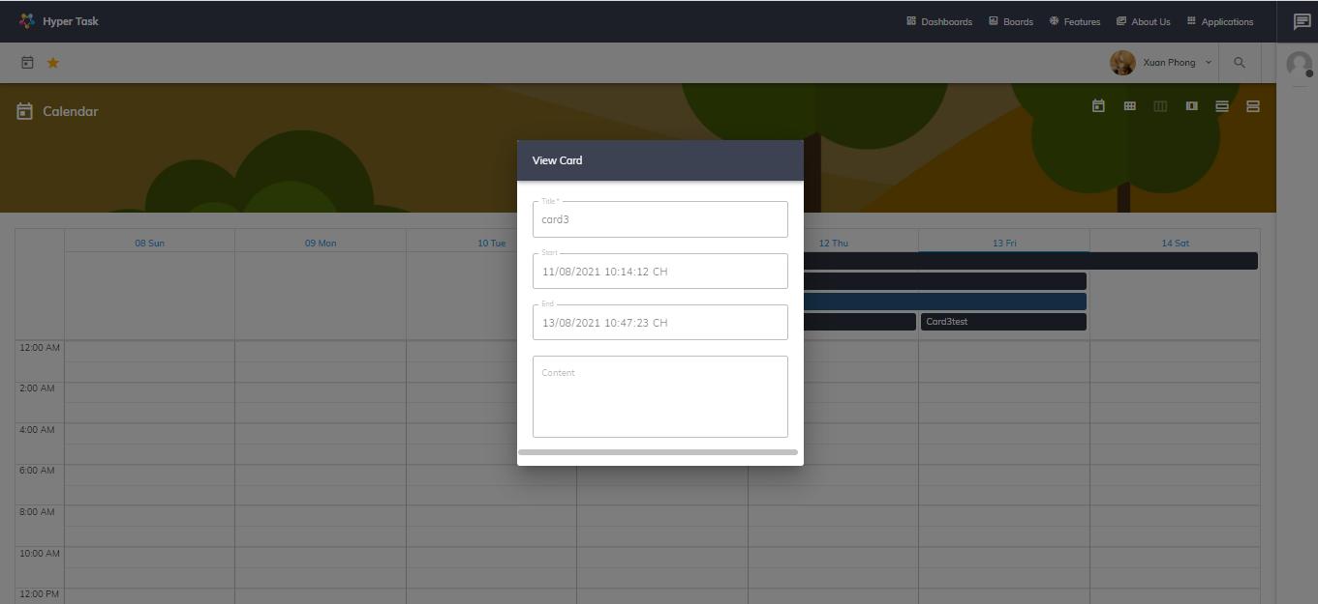

1. Card detail page

Clicking on the card will show a popup detail the due date and description of card